Property of Oklahoma Child Wellbeing
Craig Hagin Social Media Following: Screenshots, Witness Account, and Questions of Ministerial Accountability
Disclosure and Scope: This document is based on publicly available information gathered from social media platforms, public records, news reports, organizational websites, and other open sources available at the time of research. Social media content may be edited, deleted, archived, or otherwise altered after collection. The presence of Grandfather and Pastor Craig Hagin of Kenneth Hagin Ministries, Rhema Bible Church, RMAI Worldwide Ministries and Pastors for Trump in Tulsa, Oklahoma following these accounts online and any other interaction should not be interpreted, without additional evidence, as proof of endorsement, agreement, intent, participation, or knowledge. This report is intended to document publicly observable information and should be considered together with all available evidence, context, and supporting documentation.

Received 7/16/2026 via email and Facebook Messenger
STUDENT LIFE
I joined RBTC as a student in 2021 and after a few weeks I volunteered to be in Synergy every Tuesday as an usher because you're told to volunteer for something while you're there at Rhema as a student. I met a number of great people there and got to meet the one and only Craig Hagin.
The tipping point for me was after a while of volunteering, I realized Craig seemed to not care to be there, he always showed up late and was always on his phone or iPad and his sermons never made sense because he was always going on rabbit trails and going back to John 10:10, Mark 11:24 and what his grandpa did in ministry literally every Synergy meeting and then to make up going over on time (30-45 minutes over at times) by calling for a healing line and then brag about how he has a gift of healing to the people in the line (I personally don't think anyone of those people got healed in those lines).
Synergy was rough with Craig but his classes at RBTC were worse. He was in charge of the Financial Management class for 1st Year students of RBTC and I was warned by 2nd Year Rhema students about his class as being bad and getting nothing out of it. In that class he would go on rabbit trails and brag about how he had an Accounting degree so he knows what he's talking about but he would contradict himself by saying he was frugal and didn't spend money on unnecessary things or buy things on impulse and you have to budget and then the next Financial class he would share that the shoes he was wearing that day were over $250 and he bought them because he can't save money and likes buying things. (So much for being frugal and budgeting).
The 2nd Year of Rhema (2023), Craig took over a class for Pastor Hagin (I don't remember which class) but in that he made no sense either and you can tell no one cared to be there towards the end of semester and Craig knew that we didn't care and smarted off saying "Yeah y'all can finish the final for this class faster than yall can keep quiet." You could see the shock from students and oh I was so mad, I had to bite my tongue to not yell at Craig about his teaching being terrible and I almost walked out of that class but I ended up staying through the class and I stopped going to Rhema all together after graduating.
CURRENT EVENTS
June of 2025 I was on social media (as most people are) and found a funny video filmed by a woman and I went to her account to find more funny videos and discovered it to be overly sexual and was getting ready to back out of it when I noticed it was being followed by Craig Hagin which surprised me and showed my wife and a close friend which surprised them also. I later got curious as to why Craig would follow such a woman and thought "What if there are more(accounts)?" And down the rabbit hole I went.
I had found out that Craig was following numerous female profiles including OnlyFans and Playboy models and young girls that someone his age shouldn't be following on Instagram and I was shocked and dumbfounded at what I had found and I took screenshots of everything I could and in July I tried to take it to Kirk DuBois (since he was the RBTC Dean's Assistant at the time) but since he was unavailable; I was directed to {REDACTED} and gave him the screenshots and shared my story about how I got them and he said he would take it from there and said I did the right thing and would reach out if he needed anything else, I told him I wasn't trying to damage Rhema or the Hagins with this and hopefully it brings edification.
I had horrible anxiety during the whole thing from the shock of what I had found and what it was going to do to Rhema and left town for a few days to cope and de-stress from it all. I do believe that {REDACTED} turned in the screenshots but it was swept under the rug (by the Hagins), Craig did unfollow some of the profiles I had given them but not all of them. I later gave him two more accounts that I had found and I found that both women were in the Bixby/Tulsa area. I've always wanted to ask for an update on what I gave them but always had anxiety about asking and was afraid for being the bearer of bad news and then to add salt on the wound: ask for an update on the bad news. And I honestly thought they would reach out to me about what was going to happen and would pull Craig from positions he held in Rhema and be put on a sabbatical or something but he was still able to preach and teach which got me mad because I now knew his integrity wasn't there and no godly pastor or teacher would be looking at those profiles/women and any church with integrity would have immediately reprimanded him. Ever since then I've prayed for Craig to be exposed and be judged according to his works. With the recent events at Rhema with Craig, I really believe it's my prayer coming to pass and I'm honestly sad it's come to this and finding out it's bigger than just some screenshots I took

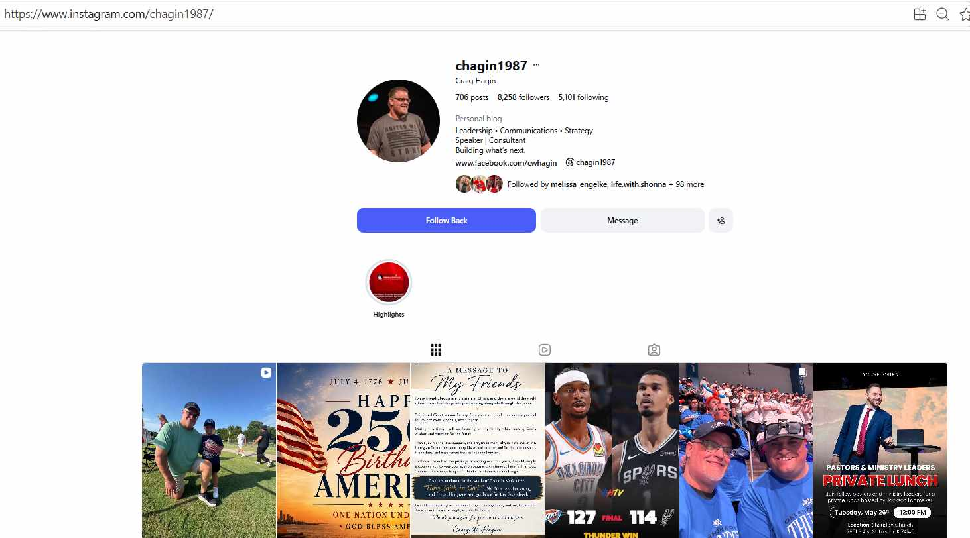

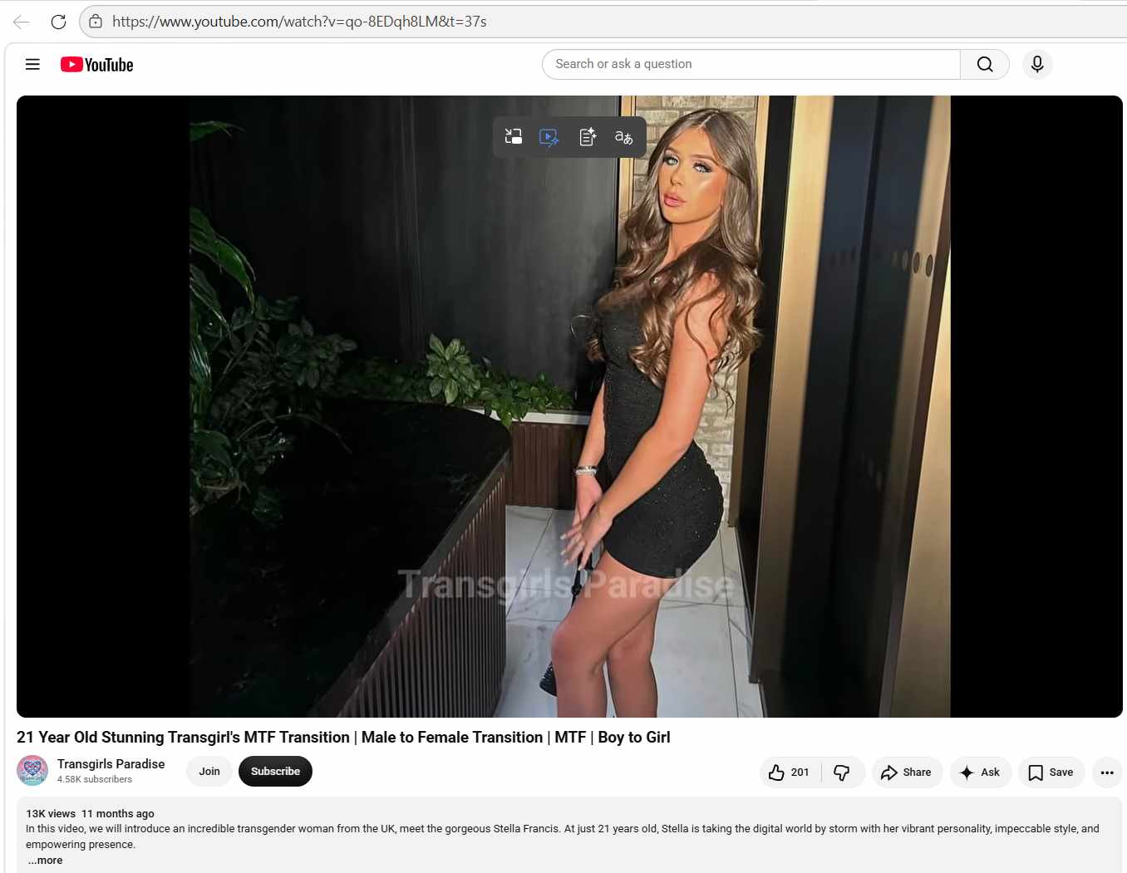

Stella Francis — Transgender Story and Public Presence
Stella Francis is a 21-year-old transgender woman from the UK who has been making waves online with her vibrant personality, fashion-forward style, and unapologetic confidence YouTube. She is active on platforms like Snapchat, TikTok, and YouTube, where she shares personal moments, fashion content, and messages of self-acceptance.
Identity and Public Identity
Stella identifies as transgender and has openly embraced her identity in her social media content. On Snapchat, she has posted moments that celebrate trans visibility, body positivity, and self-confidence, often with text overlays that reflect her journey and perspective Snapchat. Her Instagram handle is @stellafrcisxox, and she has also shared intimate vlog-style clips, such as one where she playfully says, “22, brunette and trans. Looking for love”, inviting connection while being open about her identity Snapchat.
Story of Self-Discovery and Resilience
While her public content focuses on style, confidence, and community, her TikTok profile is linked to a broader narrative about self-discovery, empowerment, and resilience. The caption for her TikTok journey video reads: “Join Stella Francis as she shares her inspiring journey as a transgender woman. Discover her story of self-discovery, empowerment, and resilience” TikTok. This suggests her story includes overcoming personal challenges, embracing her identity, and using her platform to inspire others.
Style and Influence
Stella’s content often features glamorous photoshoots, fashion-forward outfits, and confident posing, which she uses to celebrate her body and gender expression. Her style is a mix of high fashion and personal flair, making her a role model for trans women who want to express themselves authentically YouTube.
Community and Advocacy
Through her work, Stella contributes to trans visibility and LGBTQ+ representation. She shares messages of pride, body positivity, and self-acceptance, and her presence helps normalize transgender identities in mainstream media. Her journey reflects the broader trans experience — from self-discovery to public visibility — and she uses her platform to connect with both trans and ally audiences.
In short: Stella Francis’s story is one of coming out, embracing her identity, and using her creativity to inspire others. She blends personal vulnerability with bold self-expression, making her a visible and empowering figure in the transgender community.

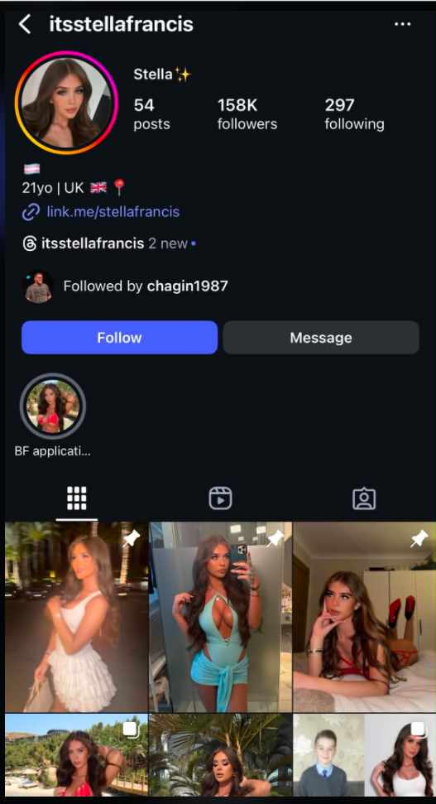

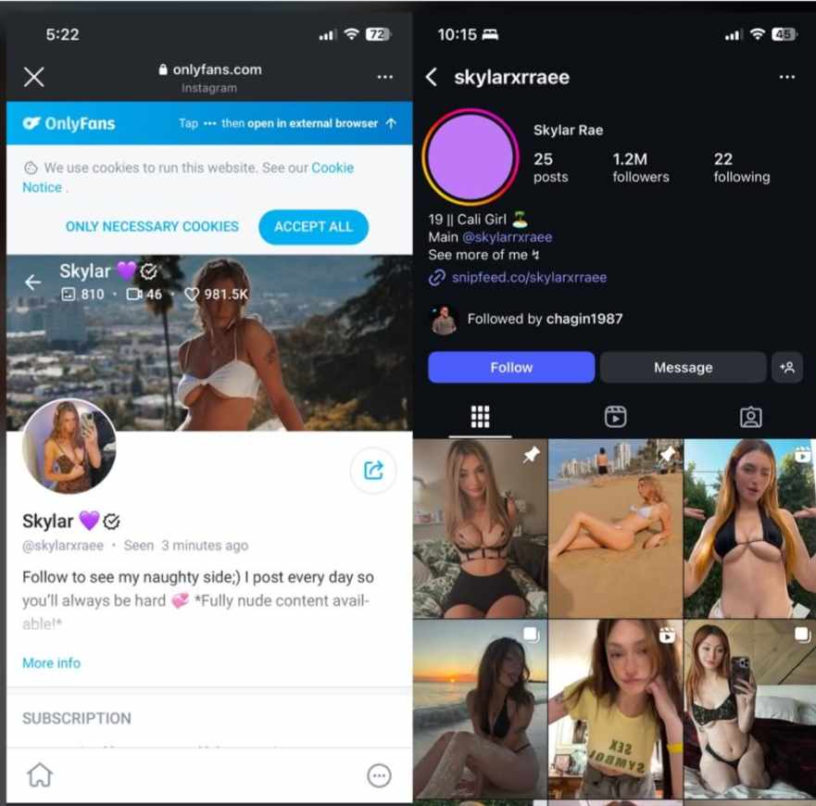
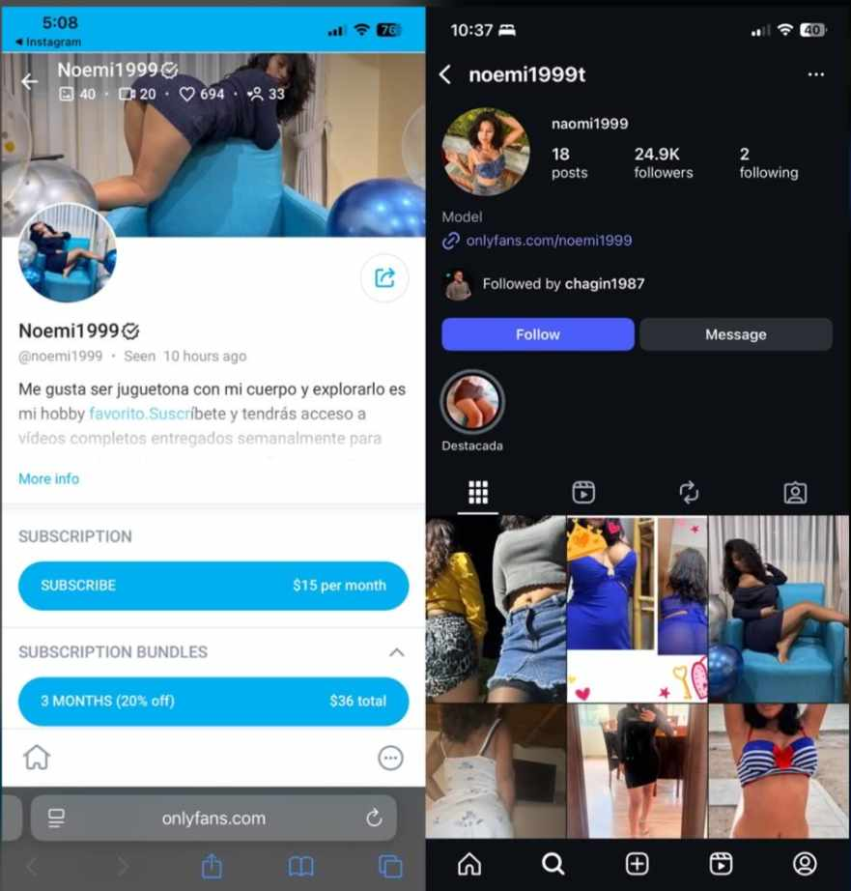
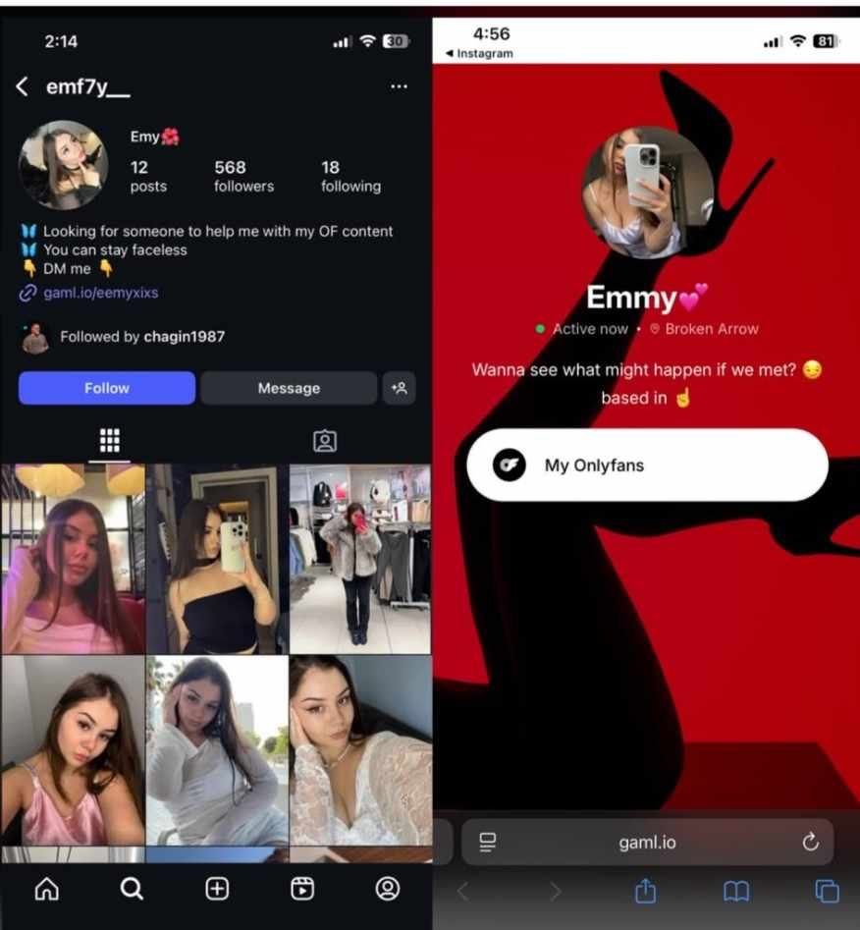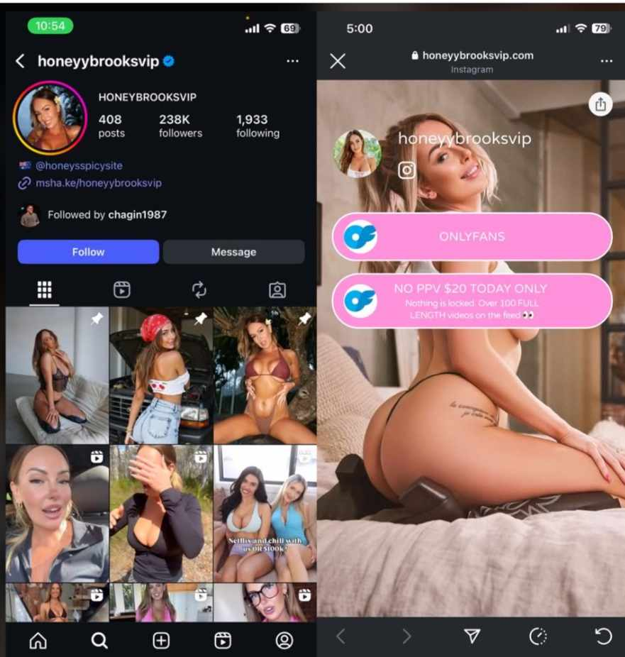

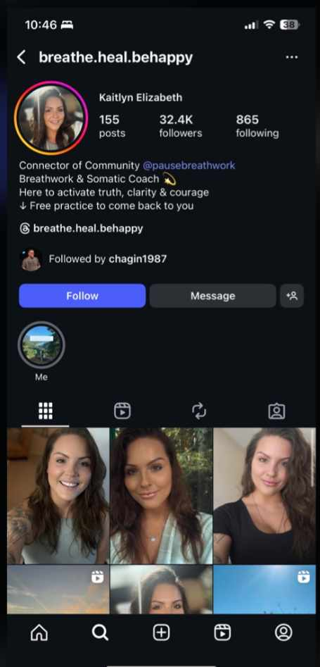
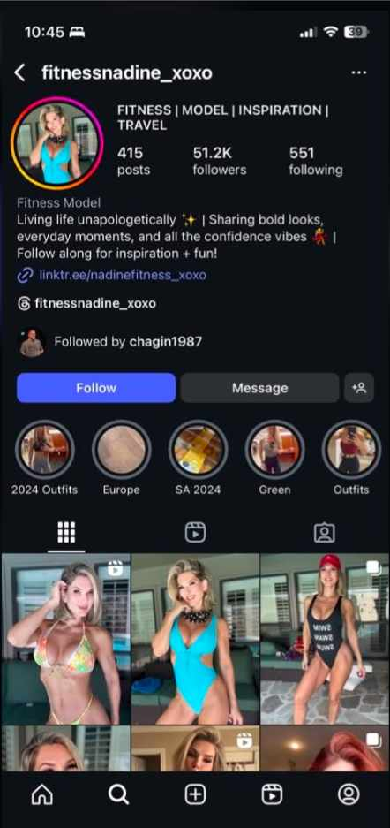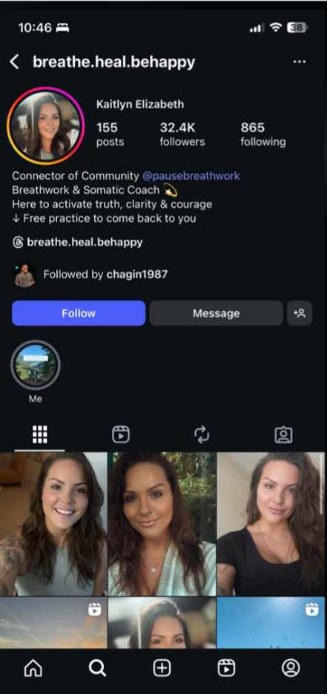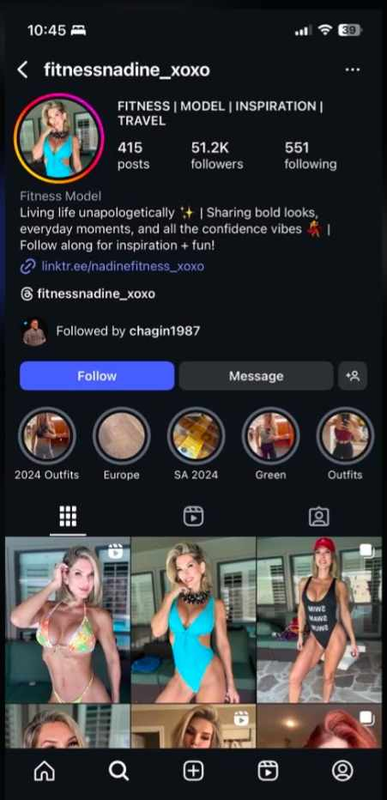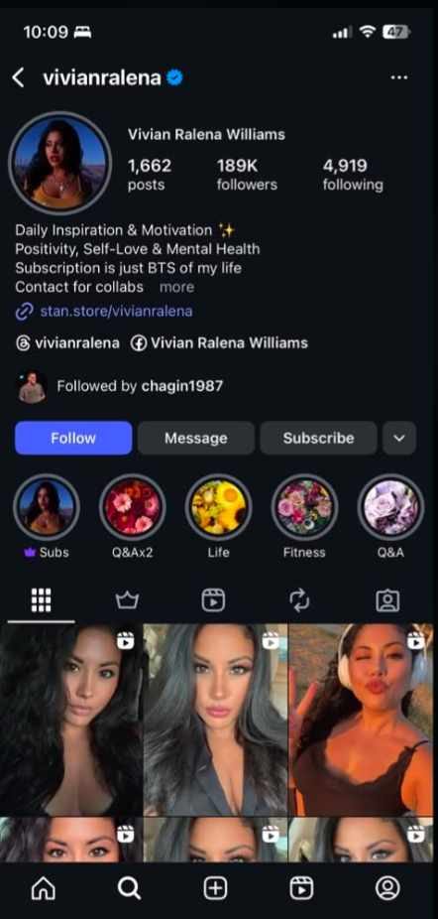

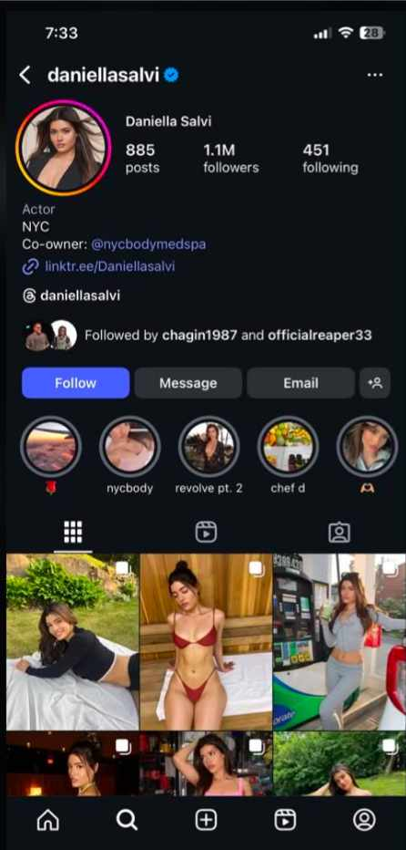
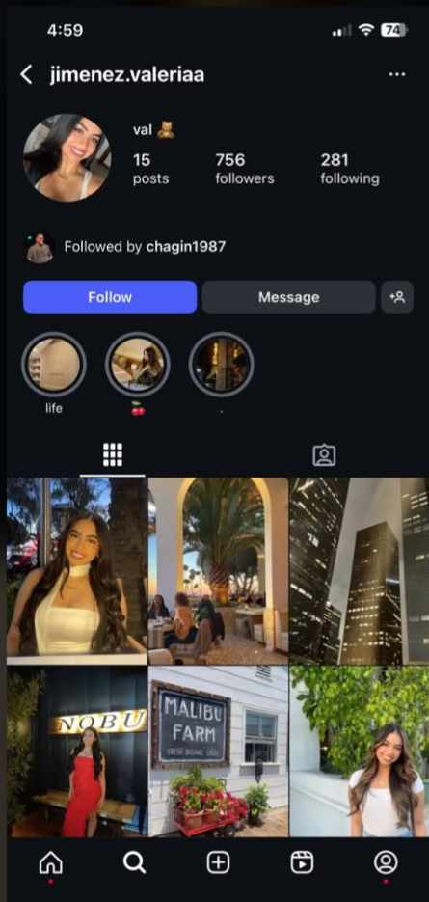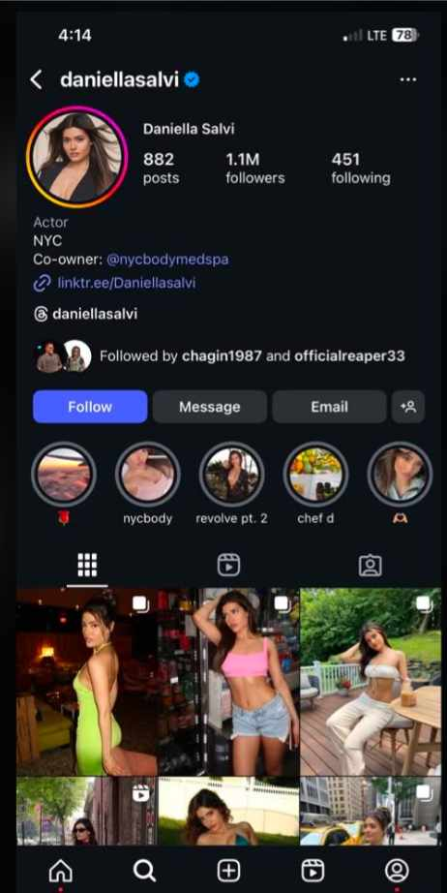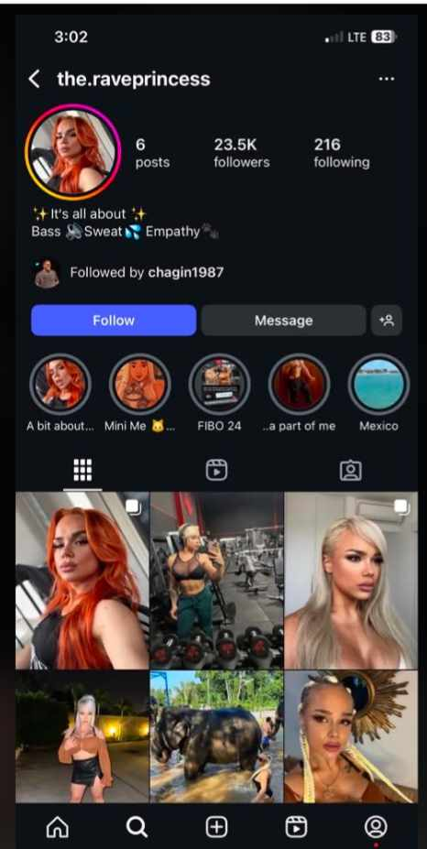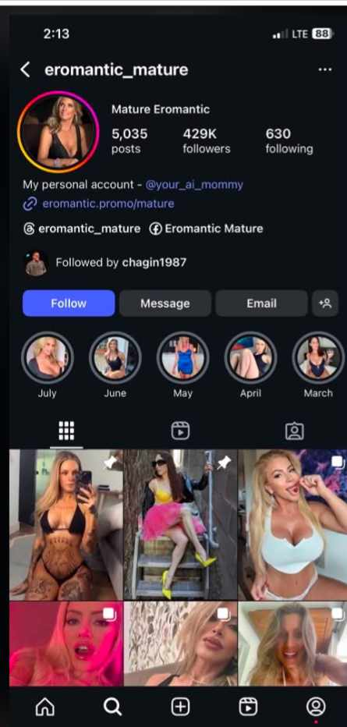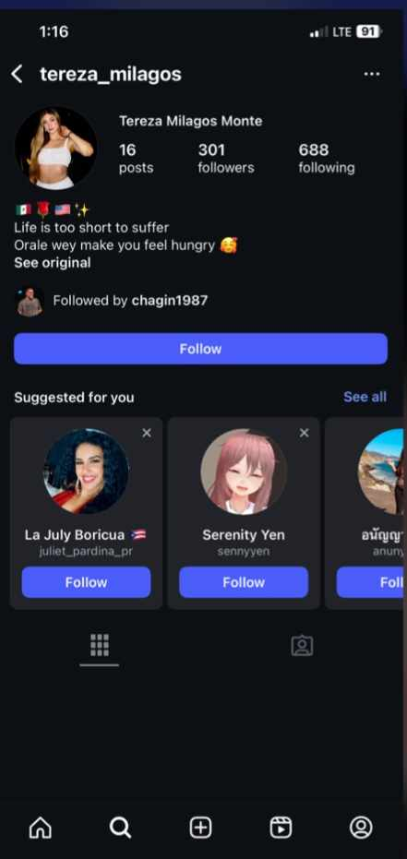
Quote: “These 2 profiles were the 2 women in Bixby/BA. Bella works at a Bar & Grill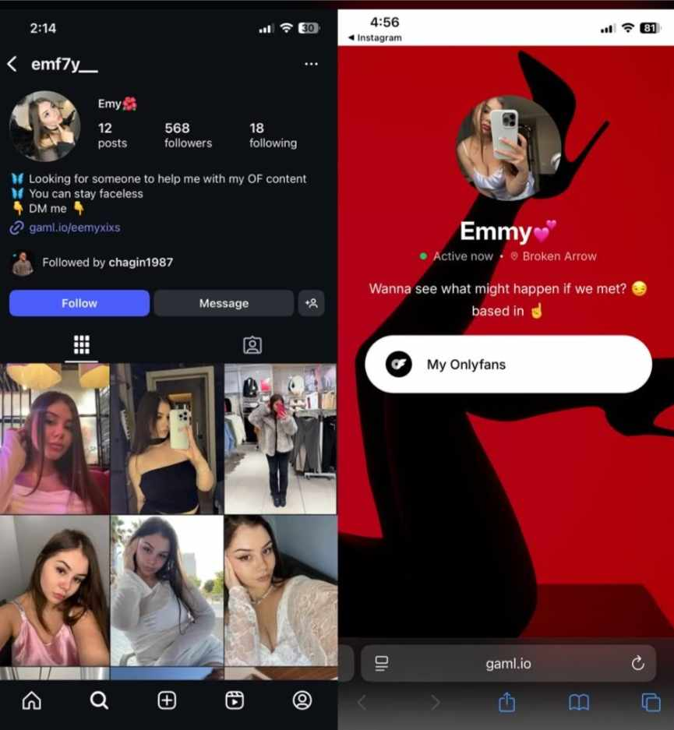
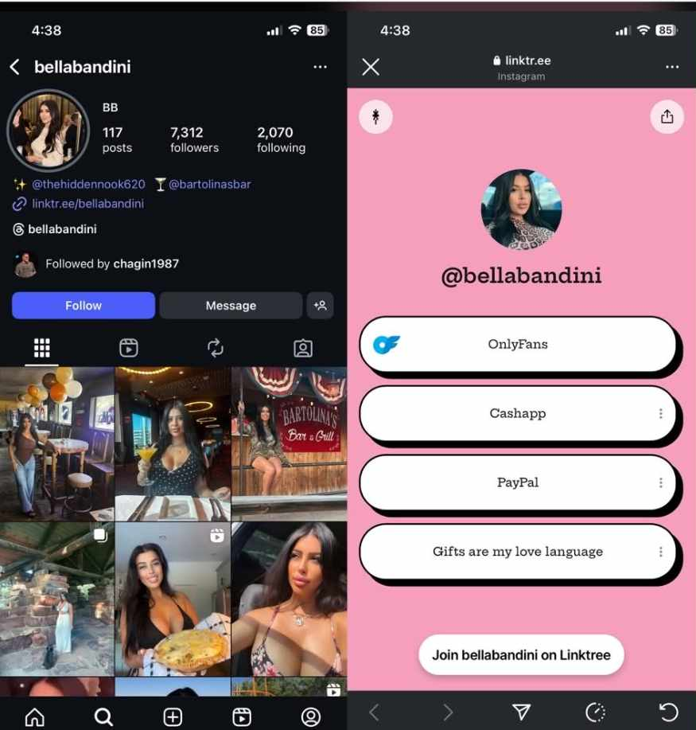

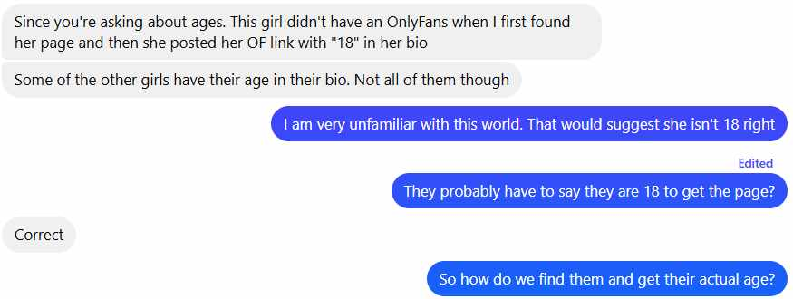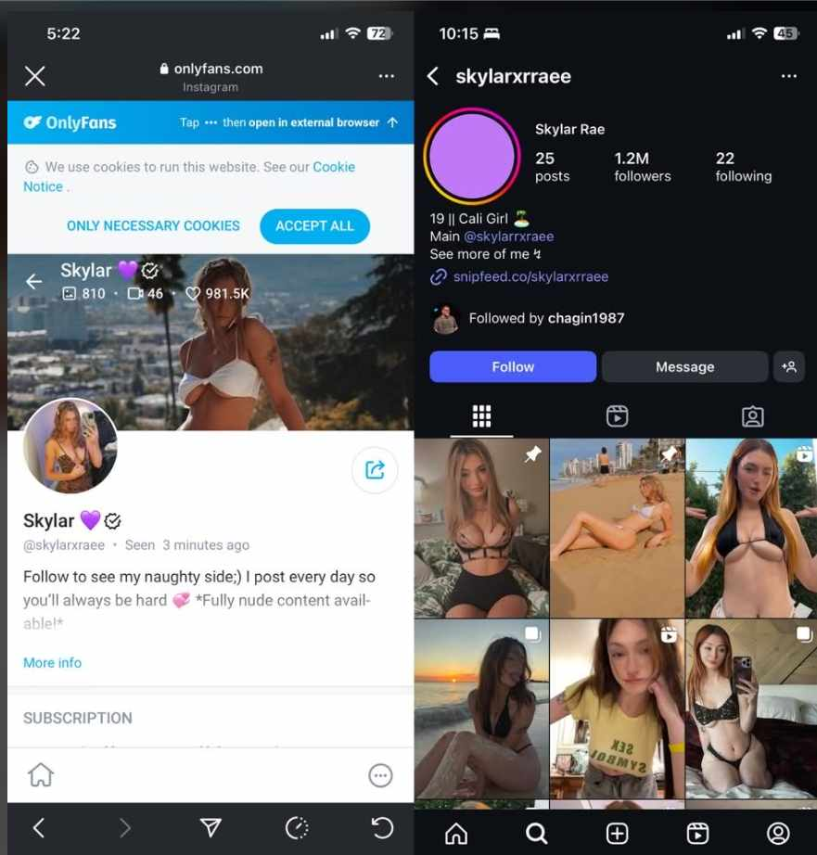
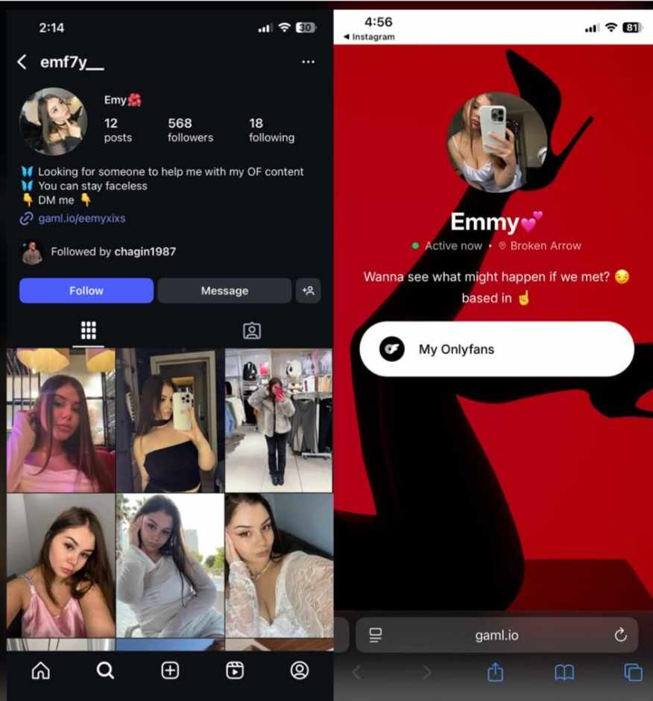
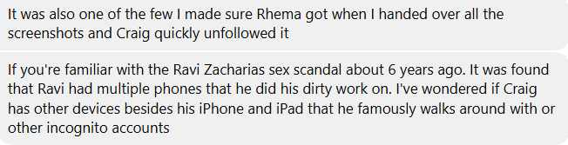
Photos to verify it is Craig Hagins official Account - He also joined Parlor with the same user name
