PROPERTY OF OKLAHOMA CHILD WELLBEING | www.okchildwellbeing.org
Disclosure and Scope: This document compiles publicly available online commentary, screenshots, and other open-source material for documentation and public-interest research. Statements attributed to commenters or third parties reflect their own views and are not presented as independently verified facts or as the views of Oklahoma Child Wellbeing. Inclusion does not constitute endorsement. Online content may be edited, deleted, archived, or otherwise altered after collection and should be evaluated with all available context, corroboration, and supporting documentation.
EXCLUSIVE: Tracey Chapman Exposes the Latest Craig Hagin & Rhema Developments
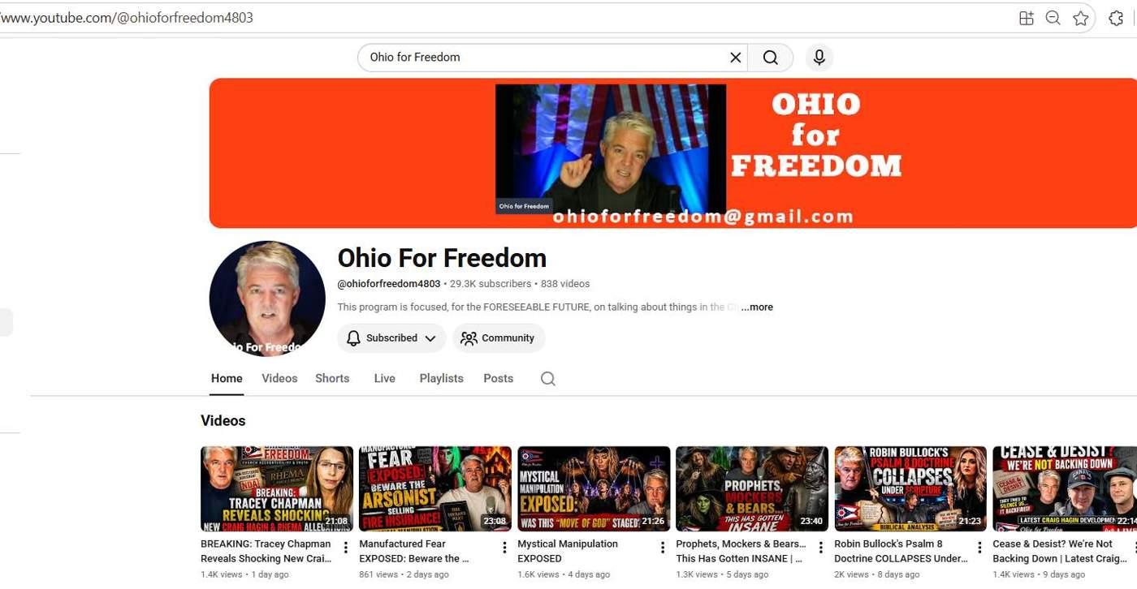
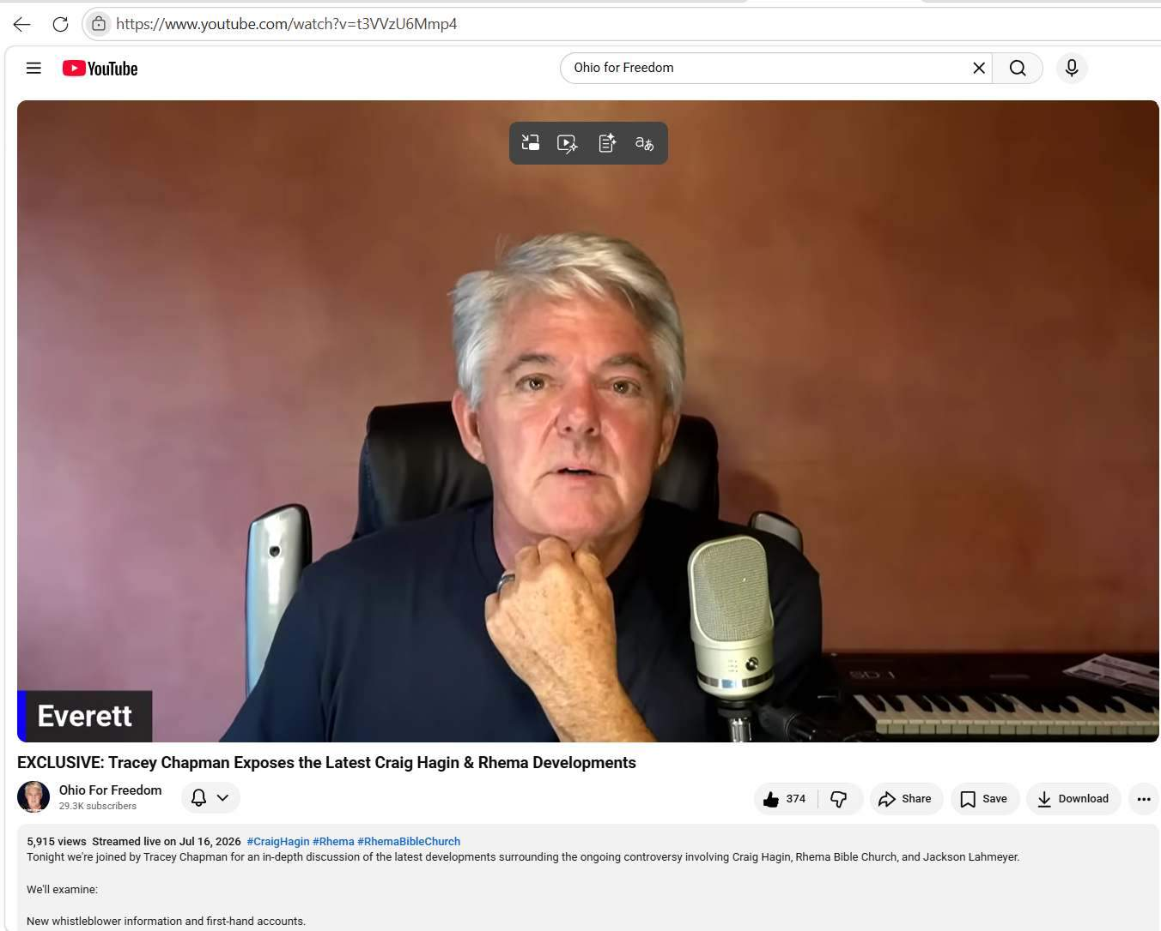
Comments from Ohio for Freedom Podcast
This that's going on in Tulsa is sickening.
Completely agree! The epitome of God central, is actually developed its own sins and excuses that God is not a part of
I like that usage "Epitome" well said
As a former social worker I love this brave young lady. Great guest !
Thank you!
Keep up the good work Everett
Great to see Tracey again. She certainly takes risks with her reporting. Keep her and her family uplifted and protected with ongoing prayers for them dear brothers and sisters 🙏😊
@OklahomaChildWellbeing
Thank you!
Cover up culture
The husband strays, but the wife repents?!
Wow!

When the foundation is cracked nothing good can come out of it

For money and power. God warned us

Beautiful description of how we should tithe! Love it!!!

Truth spoken by you both, and apparently being covered up by deception. Imperative!! TY!✝️

God bless you both!!

Wof is heretical

Go both of you! Great statement, Tracy my country is not for sale!

Her closing prayer: PLEASE PUT IT IN PRINT so we can share it EVERYWHERE!!! Thank you!!!

Grooming women and girls! Yep! To be abused by men who say submit instead of loving their wives as Christ loved the Church. And I know for a fact that there are true men of God who are not consumed by lust because my late husband and many others I have known through the years lived lives so far from this filth. Men and women who loved the Lord and His Word. The deceitfulness of riches and the idol worship of the leadership in Charismatic circles breeds this evil. And they're laying hands on people around the world! The Tulsa Cabal wing, The Dallas-Houston wing, The Ohio Kentucky wing...I agree with Tracy...pull the plug and give your money where they were supposed to spend it.

We are NOT a democracy Tracey. We are a REPUBLIC

1 day ago
Great guest, great info, Thank You Jesus!!

3 hours ago (edited)
I want to add what DianeArgue said "This that's going on in Tulsa is sickening." So please pray for the Tulsa Metro they have over 1 million people. Have not the local people and Christians suffered enough with a mountain of strangefire famous Ministries there for decades now. So we pray more than ever they will stand up and say NO MORE ENOUGH OF IT

1 day ago
LOVE her! Great guest!

1 day ago
Cult is right

1 day ago
Thank You Everett for this discussion with Tracey Chapman. a big 👍🏼💪🏼!
♥♥

Hagin jr. is awful

1 day ago
Church in Tulsa, Ok wake up and REPENT.

I truly agree with Lynn and Tracey. I went to a church for years where all the money went to pay off women to keep them silent. I am a 73 year old who doesn't have enough money to cover my bills. ❤

So sorry to read this. Were the perpetrators finally exposed?

​ @MissRobyn007Sparkie yes they were. They are all decreased now. For years we planted in bad soil!❤ The church began to follow Carlton Pearson and teaching a false doctrine and I had to leave. I went to Tulsa every year for the AZUSA conferences and all of a sudden he didn't believe what he was teaching. So 😔

Thank you,Tracie and Everett, thanking The Lord, for revealing truths to me! Thank You, Father❤❤❤❤

Everett thank you for having this courageous, honest, woman, lover of God and His truth, on. May more people come forward with the truth.

I am having a hard time believing that Rhema’s leadership said rape is the victims fault. If you have recorded evidence, please share. Thanks

Jackson Laymeyer needs to be removed from ministry.

Excellent interview/discussion…..Tracie is a breath of fresh air in this murkiness…..Well done, bro Everett!🫶😇🕊️🙌
You’re so lovely….Hope you have a super blessed day, dear lady!💗🥰

Funny how many pastors who have visited the White House have been EXPOSED as wolves.
Still find it interesting that in Jer. 23, God’s judgment & wrath was not directed to the “rulers” but to the prophets & priests.

1 day ago
The charismatic movement, the name it and claim it, the healing message and prosperity gospel has done more to hurt the church than any other movement we have had. Lord keep stirring the mud and bring the bad stuff to the top. Expose it all Holy Spirit!

I do not understand why no one called the police🤷‍♀️

Sorry when they aren’t true Pastors of God’s Word when they worship another God they are a cult worshiping mother moon. Praying for President Trump to see the light and for his Family 🙏🏻

There is no Fear of The Lord! A wake up call is needed and is sure to come. It is time for us to choose a side, for the line has been drawn and Justice is coming and it will not be pretty. For GOD will not be mocked. Heaven help the blind, deaf and dumb!

Great guest !!!
💯% Genuine! 🤍
I, personally, am
not a fan of any of the Hagin’s - but I sure see God’s hand in her there.
GOD bless and keep this precious Sister and bless the work of her hands.

teaching financial classes at Rhema WHEN having his wages garnished at Rhema 10-20 times over the years, even with 1st wife Missy Pittman

Did a quick chat gpt. Tulsa was ranked 2 in domestic violence, OKC was #1. Sheesh. Tulsa did not rank for poverty.

Anointing machine nice 👍 Do you have a mantle machine? I don’t wanna grave soak to spooky for me. Can I just get one outta the mantle machine for like a love gift of $500.00 or more?

Kendra was the Children’s Pastor or Director is that correct? If so what happened why are they hiring!?

Church Internships

Tracey just doesn't understand economics. Minimum wage laws are not the way out of poverty for real life people. If employers don't think somebody is going to provide them with more than minimum wage level value as a worker, to keep them from going to another employer, then they aren't going to hire that person at all. And when that person is not hired at all they're not going to be able to afford any bouquets to throw at the advocates of minimum wage increases.

Having said that I feel only abhorrence at the Christian ministries like Karen Wheaton's Ramp and David Taylor that are practicing slave labor. We need to tear down the "touch not the Lord's anointed" and "armor-bearer" theologies that support this kind of exploitation.

Shes talking about the fact that Rhema pays their workers low or minimum wage and tells their workers it's a privilege to work for the ministry. Meanwhile, bigwigs are getting paid 500K from tithes and offerings, money people give that they don't even have - and are using it to pay for prostitutes, blackmail, drugs, etc.

Go look now at recent Rhema Sunday morning services for their morning announcements. You'll see the way they frame working there, they're asking for help right now.

I know people that worked there when I went to school that had to work multiples jobs and couldn't feed their families and when they asked for a raise to move TOWARD a fair wage for the job done (think of a mechanic, not being paid the going market rate, but far below) - they were told no, its a privileged to work for the ministry, you basically need to sacrifice and its acted like ministry is poor.

​she is talking about the state law in Oklahoma and that's what I was addressing in my first paragraph. But I agree with you about the practices of these big shot ministries. Their attitude that it is a privilege to work for them for little or nothing is indeed disgusting and worthy of divine judgement.

It works in Tennessee, 💰💰💰💰💰💵💵💵💵💵💵 I lived in Middle Tennessee and should never have the title Bible Belt

I think the term Bible Belt is a demon spirit. That’s my opinion.

Hagin sr. Was deceived too.

what is Tracey's website?

Sheridan Church used to called Sheridan Christian Center Back in 1976 Billy Joe Daugherty became Pastor.. the church had about 300 people.. around 1981 it grew to 1500 or so people.. Billy Joe Daugherty wanted to relocated the Church or change the name and possibly restructure the board, im not Sure. So he decided to Start Victory Christian Center around 1981...

Before I attended Victory I went to a small Assymbly of God Church.. The Pastor said several local Pastors Told Billy Joe it was not God to start his own Church...

Not saying I agree or disagree with it however theres the Back Story... Billy Joe Daugherty Passed Away Thanks giving Day or weekend of 2009 after a battle with Lympoma. He was a Word of Faith preacher. Compared to most out there i would consider Him to be word of faith lite...

@OklahomaChildWellbeing

I have studied some on the tie to Sheridan Church and Kenneth Hagin Ministries / Rhema Bible Church and it does go back to the foundation.

@OklahomaChildWellbeing Yes, I believe thats where Rhema had their first classes, before they had their own buildings? Something like that.

1 day ago (edited)
It seems that I recall that back in the 1980s Billy Joe would host a yearly conference that brought in most of the charismatic big shots. I figured Oral Roberts probably had some sort of a part in it since it was in Tulsa. I don't think that since then the charismatic big shots have tried to all get together at one time

If someone wants to sin do it but don’t do it as a leader in the Body of Christ especially as a Pastor

I think I understand what you are saying. But we should be encouraging people not to sin , regardless of what position they are in.

You should hear from Nathan R. what general Fly.. has been involved with. That guy is in bed with satan himself.

Randy Caldwell is a false teacher. He's been a horrible influence on Jackson.

A man (or a woman) who cheats in the marriage has no excuse before God. Emphatically clear. But, let's not stop there. Sexual withholding by a spouse (man or woman) puts a colossal stumbling block in the way of the suffering spouse. This is also inexcusable, especially when it becomes chronic and manipulative (See 1 Cor. 7:1-5). This is an epidemic issue in many marriages in the US today, and it needs to be recognized and addressed. Withholding spouses will be held accountable before God.

When I attended Rhema Pastor Hagin always disclosed when people were taken down from the pulpit. I disagree with Tracie about Rhema not disclosing things going on in the church. The Hagins are Godly people and you should pray for them, they have done alot of good to many.

amen ❤❤
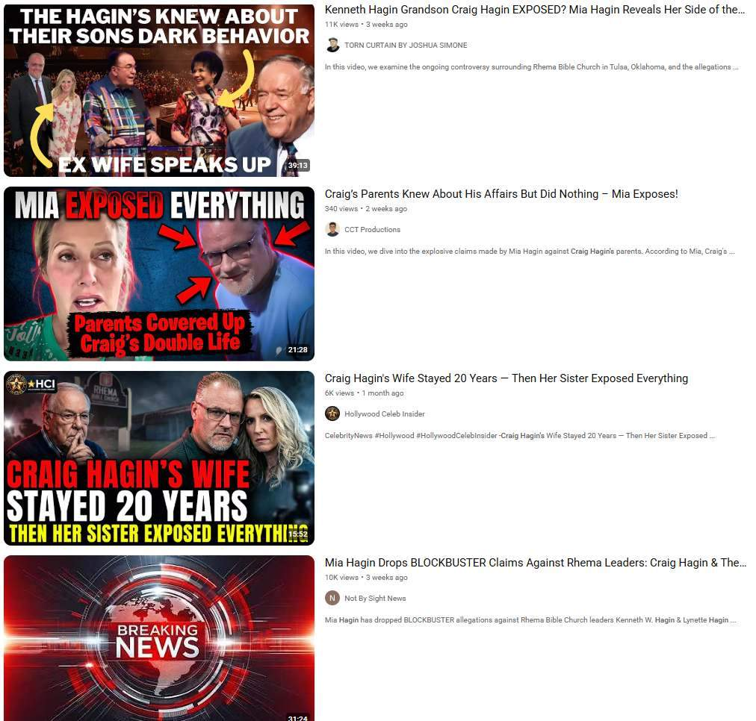
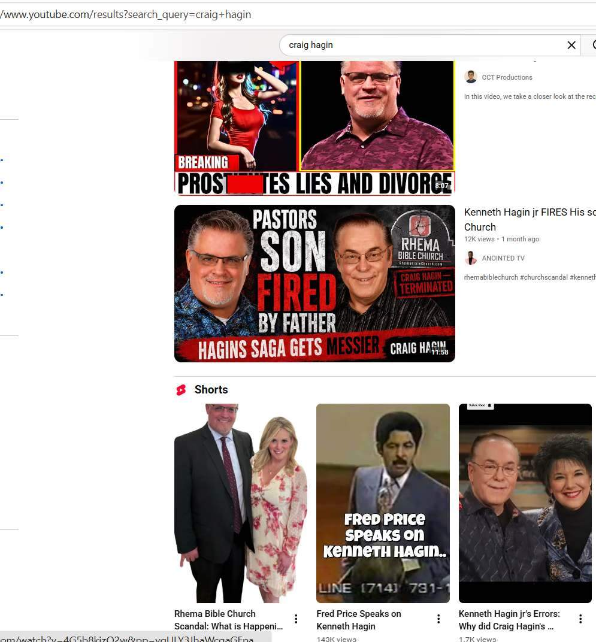
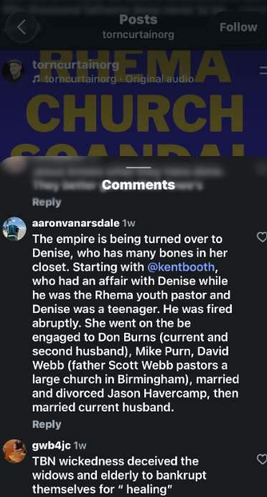
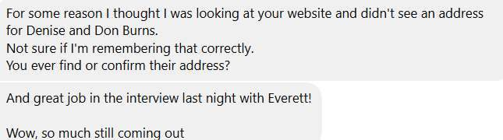

Reported Value of Co Pastor of Rhema Bible Church and Kenneth Hagin Ministries Denise Hagin Burns and Don Burns personal residence

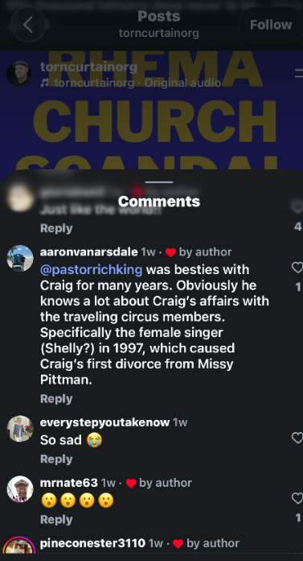

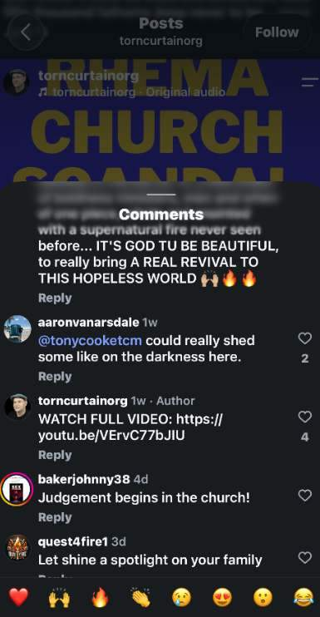

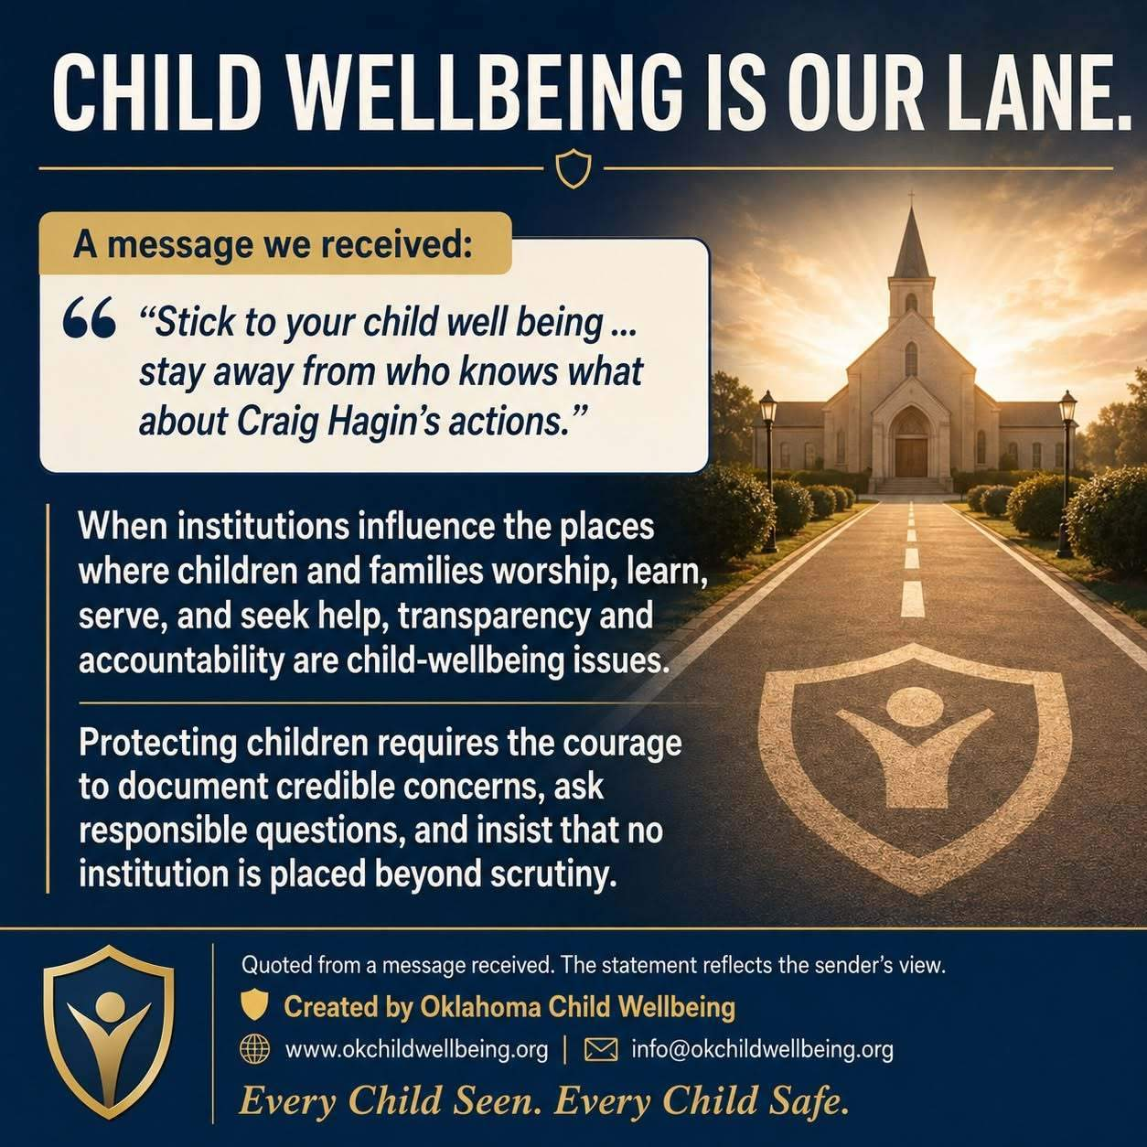
Dean Hawk Pastor at Rock Family Church in Colorado
STAY OUT OF IT” IS NOT ACCOUNTABILITY
When someone reports that pastors knew about serious concerns and remained silent, the responsible response is not to tell child advocates to “stay out of it.” The responsible response is to address the concern directly:
Who knew? What did they know? When did they know it? What action did they take? Were vulnerable people protected? Were concerns properly reported and investigated?
Asking these questions does not presume anyone’s guilt. It seeks facts, transparency, due process, and accountability. Dismissing the person raising the concern does nothing to resolve the underlying issue.
Child wellbeing does not stop at the church door. When institutions influence children and families, their leadership, culture, and response to credible concerns are absolutely child-wellbeing issues. Silence is not transparency. Deflection is not accountability. Telling people to stay out of it is not an answer.
**Created by Oklahoma Child Wellbeing**
[www.okchildwellbeing.org](http://www.okchildwellbeing.org)
[info@okchildwellbeing.org](mailto:info@okchildwellbeing.org)
*Every Child Seen. Every Child Safe.*
#OklahomaChildWellbeing #ChurchAccountability #InstitutionalAccountability #ProtectTheVulnerable #TransparencyMatters
See less
— at Rock Family Church.
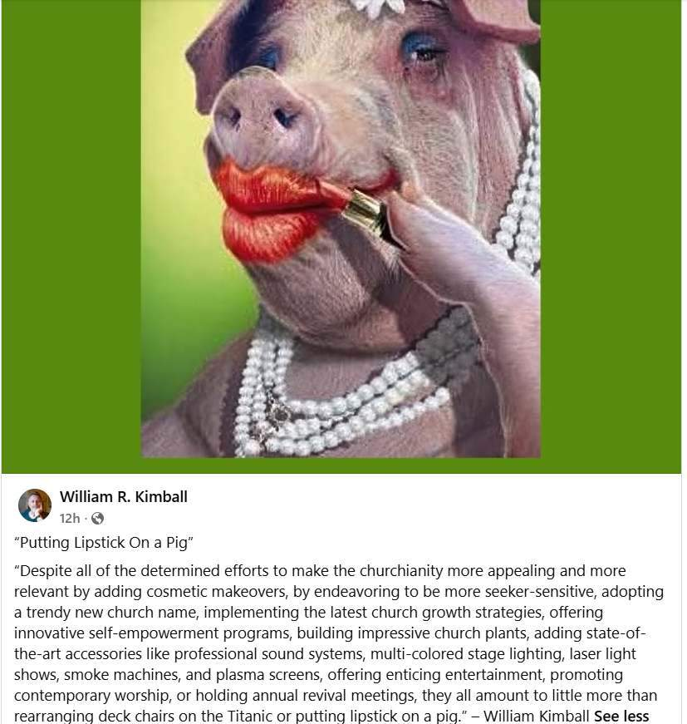
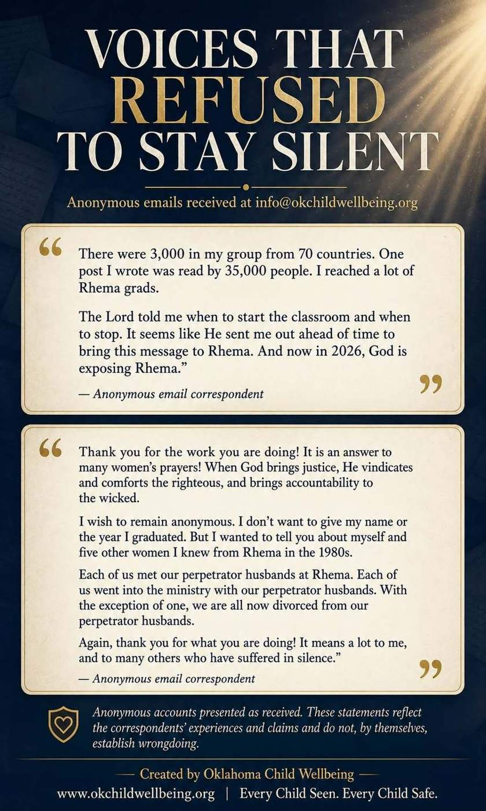
VOICES THAT REFUSED TO STAY SILENT
These anonymous emails remind us why accountability work matters. Behind every institution are people whose experiences may have been minimized, dismissed, or kept hidden for decades.
We are sharing these statements as they were reported—not as independent proof of wrongdoing.
Every allegation deserves careful documentation, appropriate corroboration, due process, and an impartial investigation. An institution’s reputation must never become more important than truth, safety, or the people who may have been harmed.
To every survivor and witness: you control your story. You may contact us anonymously, request confidentiality, or simply ask questions before deciding what to disclose.
Your identity will not be published without your informed permission, subject to any applicable mandatory-reporting obligations.
Silence protects systems. Truth creates the possibility of accountability, healing, and meaningful reform.
[info@okchildwellbeing.org](mailto:info@okchildwellbeing.org)
[www.okchildwellbeing.org](http://www.okchildwellbeing.org)
Every Child Seen. Every Child Safe.
#OklahomaChildWellbeing #InstitutionalAccountability #SurvivorVoices #ChurchAccountability #ProtectTheVulnerable #Oklahoma #IRS

Calling It “AI” Does Not Make It Fake
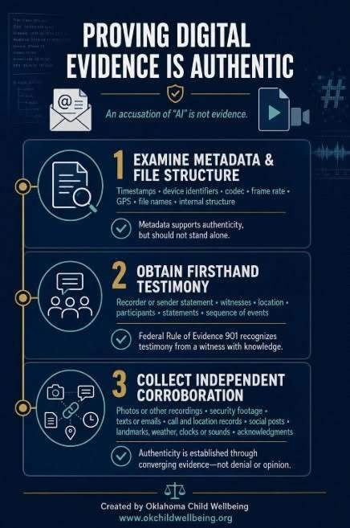
As artificial intelligence becomes more common, simply accusing an email, photograph, audio recording, or video of being AI-generated simply does not allow credible evidence to be erased.
Digital evidence is evaluated through a structured, professional process:
First, the metadata and internal file structure, including timestamps, device identifiers, file names, codec, frame rate, GPS information, email headers, routing information, and consistency with other files produced by the same device or account are examined.
Second, firsthand testimony is obtained. The sender, recorder, recipient, or witness explains when, where, and how the evidence was created or received and confirm whether it accurately represents what occurred. Federal Rule of Evidence 901 recognizes testimony from a witness with knowledge as a method of authentication.
Third, independent corroboration. Other recordings, photographs, security footage, messages, location records, social-media posts, identifiable landmarks, weather conditions, background sounds, and acknowledgments from the people involved can all strengthen authenticity.
No single factor stands alone.
Authenticity is established when metadata, firsthand knowledge, file structure, chain of custody, and independent evidence converge.
A denial is not a forensic finding. An accusation of “AI” is not evidence. Examine the facts.
Oklahoma Child Wellbeing
Every Child Seen. Every Child Safe.
www.okchildwellbeing.org
#DigitalEvidence #VideoAuthentication #ForensicInvestigation #EvidenceMatters #oklahomachildwellbeing #busted #church #Oklahoma

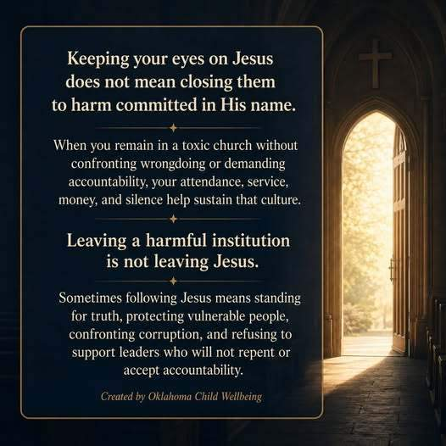
Keeping your eyes on Jesus does not mean closing them to harm committed in His name. When you remain in a toxic church without confronting wrongdoing or demanding accountability, your attendance, service, money, and silence help sustain that culture.
Leaving a harmful institution is not leaving Jesus. Sometimes following Jesus means standing for truth, protecting vulnerable people, confronting corruption, and refusing to support leaders who will not repent or accept accountability.
#church #Cartel #unitedstatesofamerica #freedom #safety #Ethics
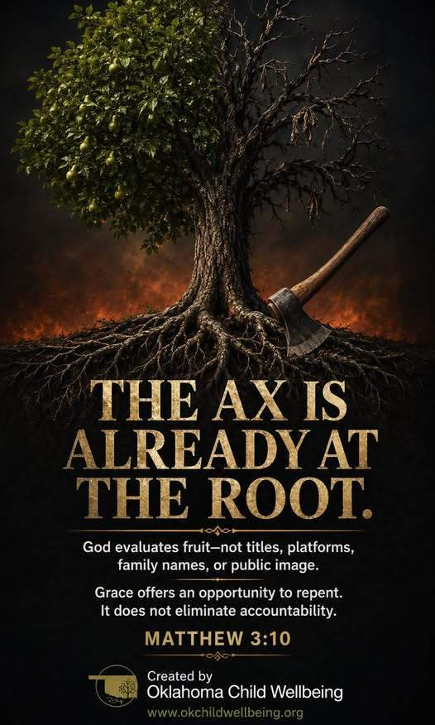
The Fruit Tells the Truth
Matthew 3:10 reminds us that God evaluates fruit—not titles, platforms, family names, religious language, or public image. Genuine repentance produces visible change through truth, humility, justice, protection of the vulnerable, and accountability. Grace offers every person an opportunity to repent, but it does not excuse continued harm, silence legitimate concerns, or eliminate consequences. When words and conduct conflict, the fruit reveals the truth.

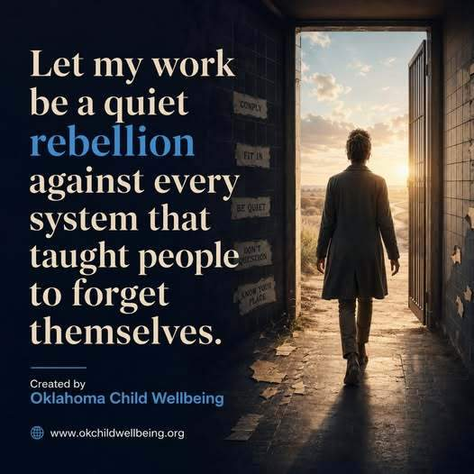
Advocacy is not about speaking over people—it is about standing beside them until their voices can no longer be ignored.
The oppressed are not truly voiceless. Too often, their voices have been dismissed, discredited, threatened, or deliberately silenced by systems more concerned with protecting power than protecting people.
Our work is to listen without judgment, document the truth, challenge injustice, and create safer paths for survivors and witnesses to speak. We must use whatever influence we have to open doors—not control the story once those doors are opened.
Let our work be a quiet rebellion against every system that taught people to forget their worth, doubt their experiences, or remain silent for someone else’s comfort.
Every person deserves to be heard. Every victim deserves protection. Every system must be accountable. Oklahoma Child Wellbeing Every Child Seen. Every Child Safe.
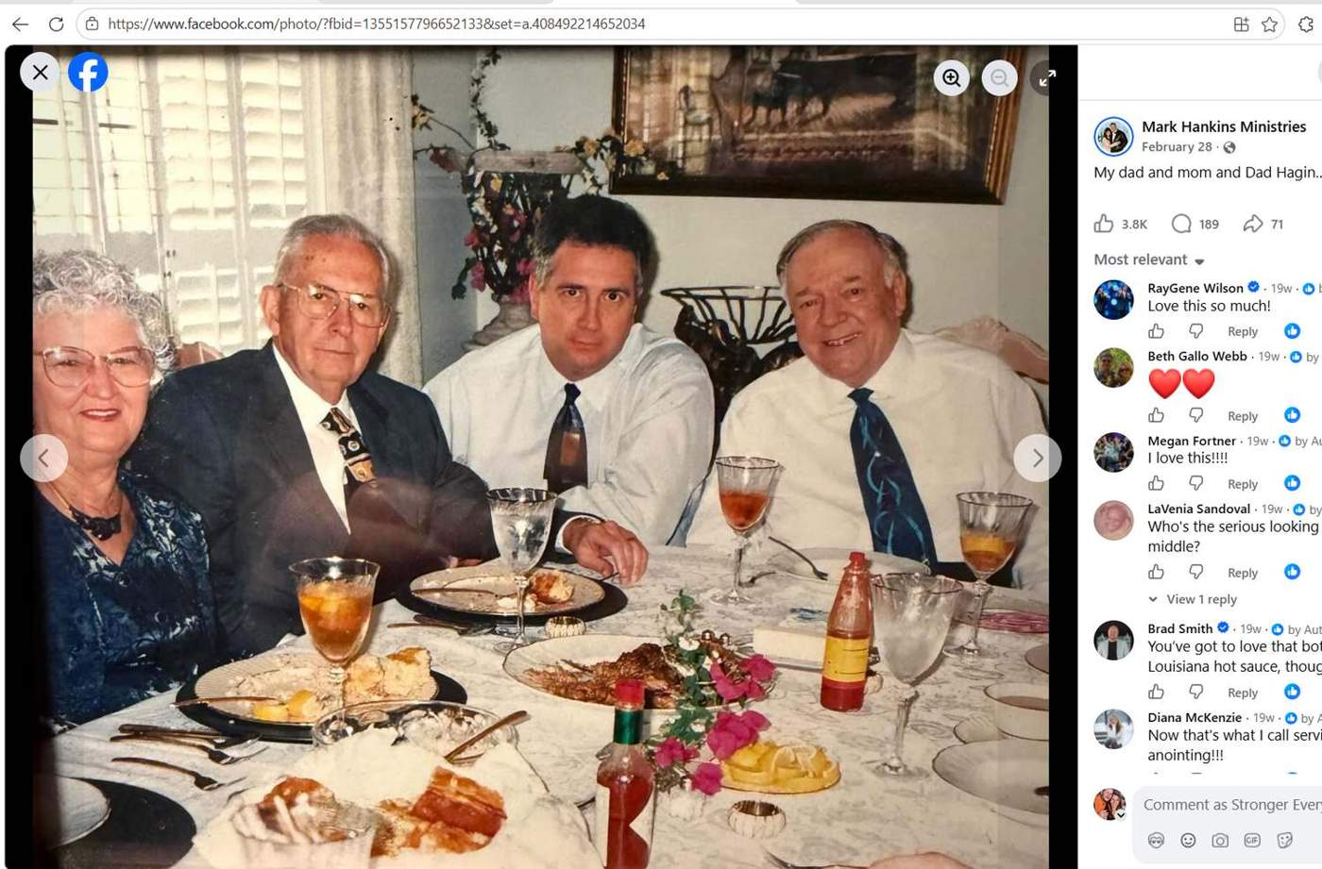
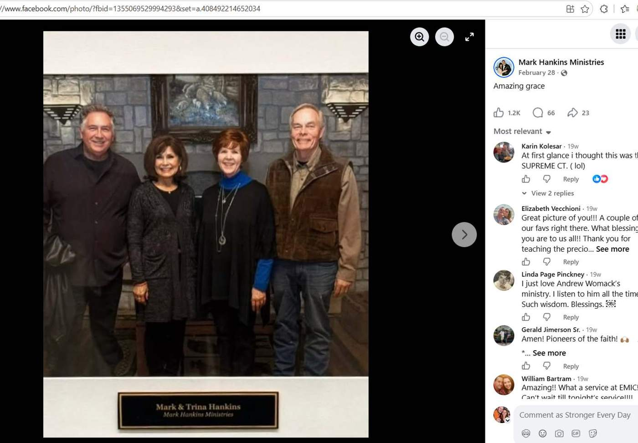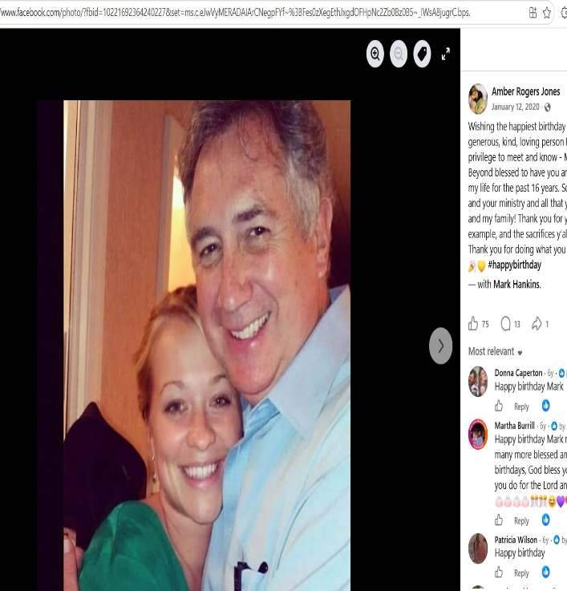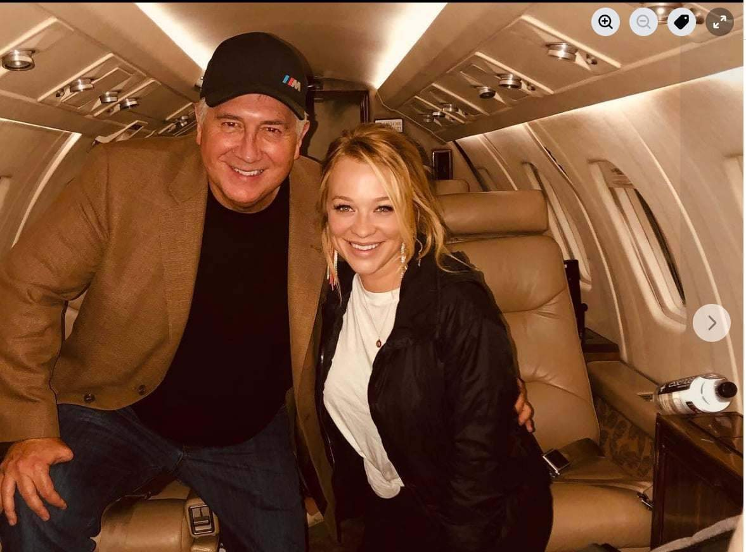
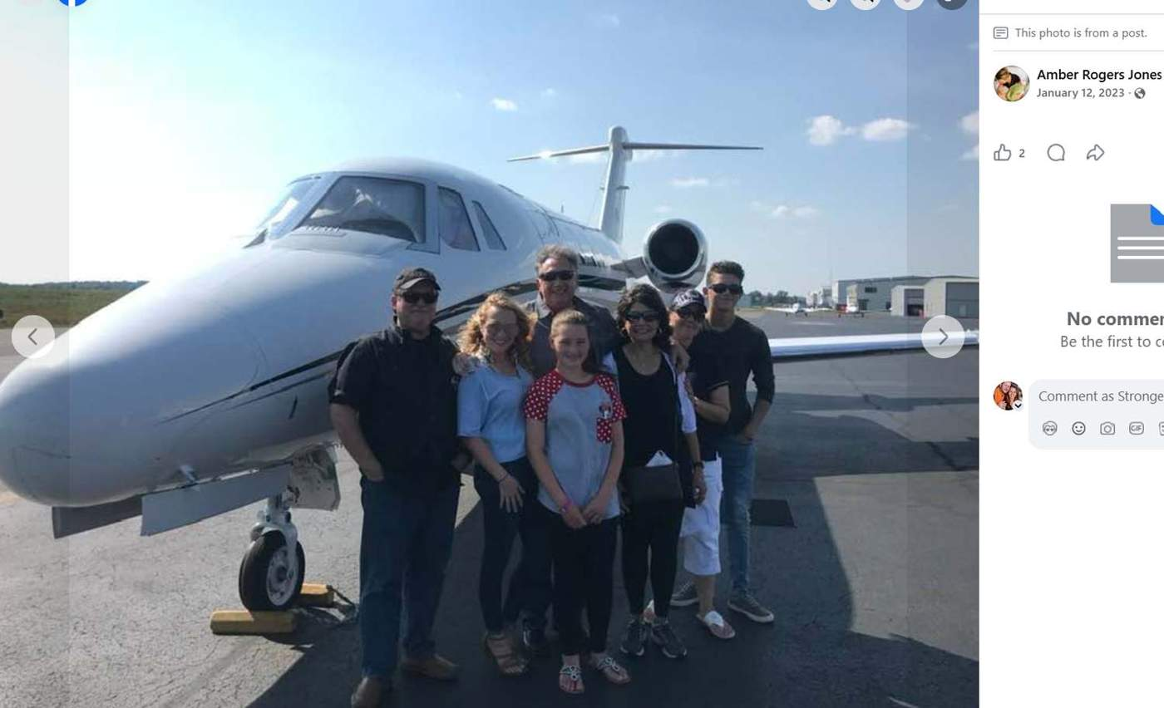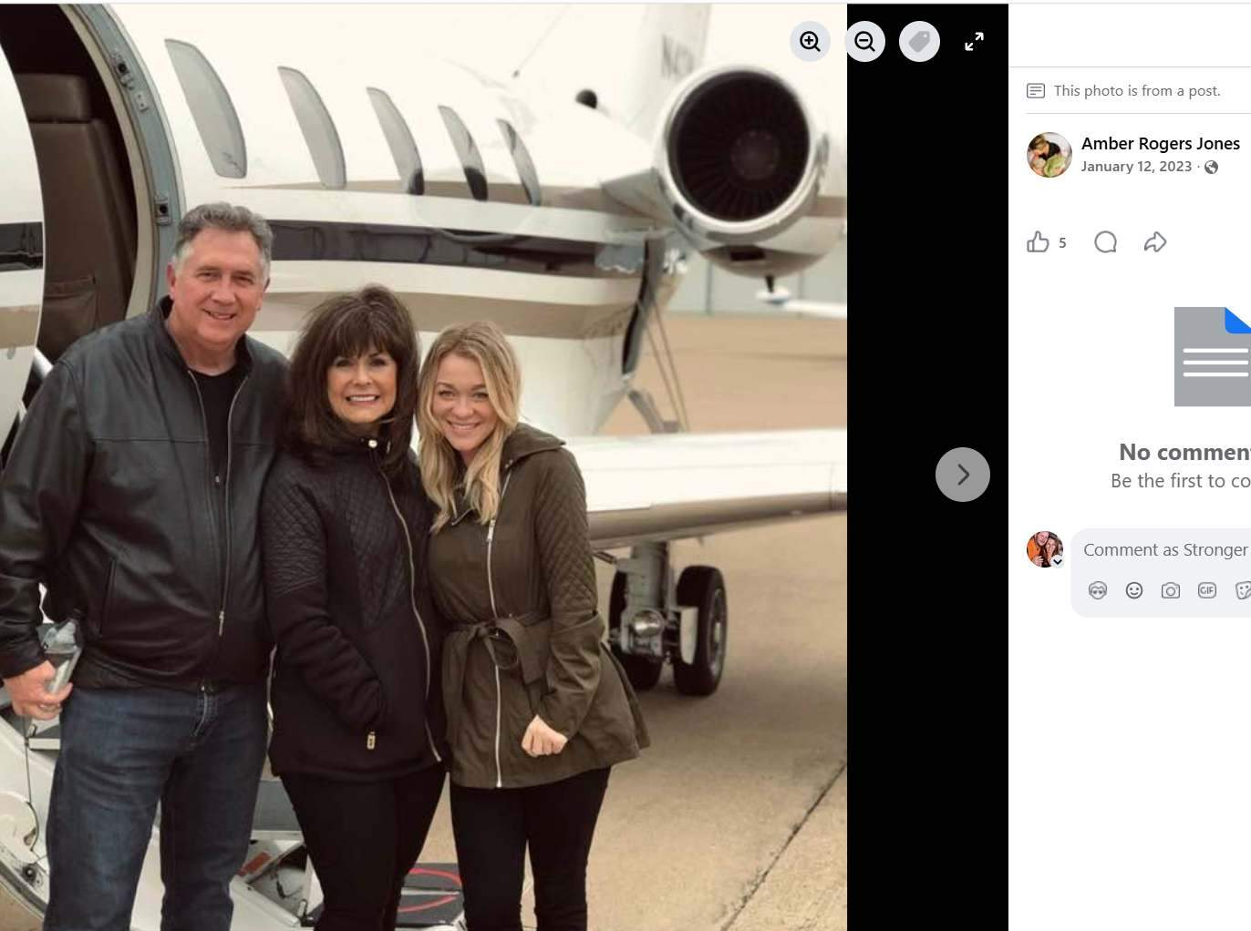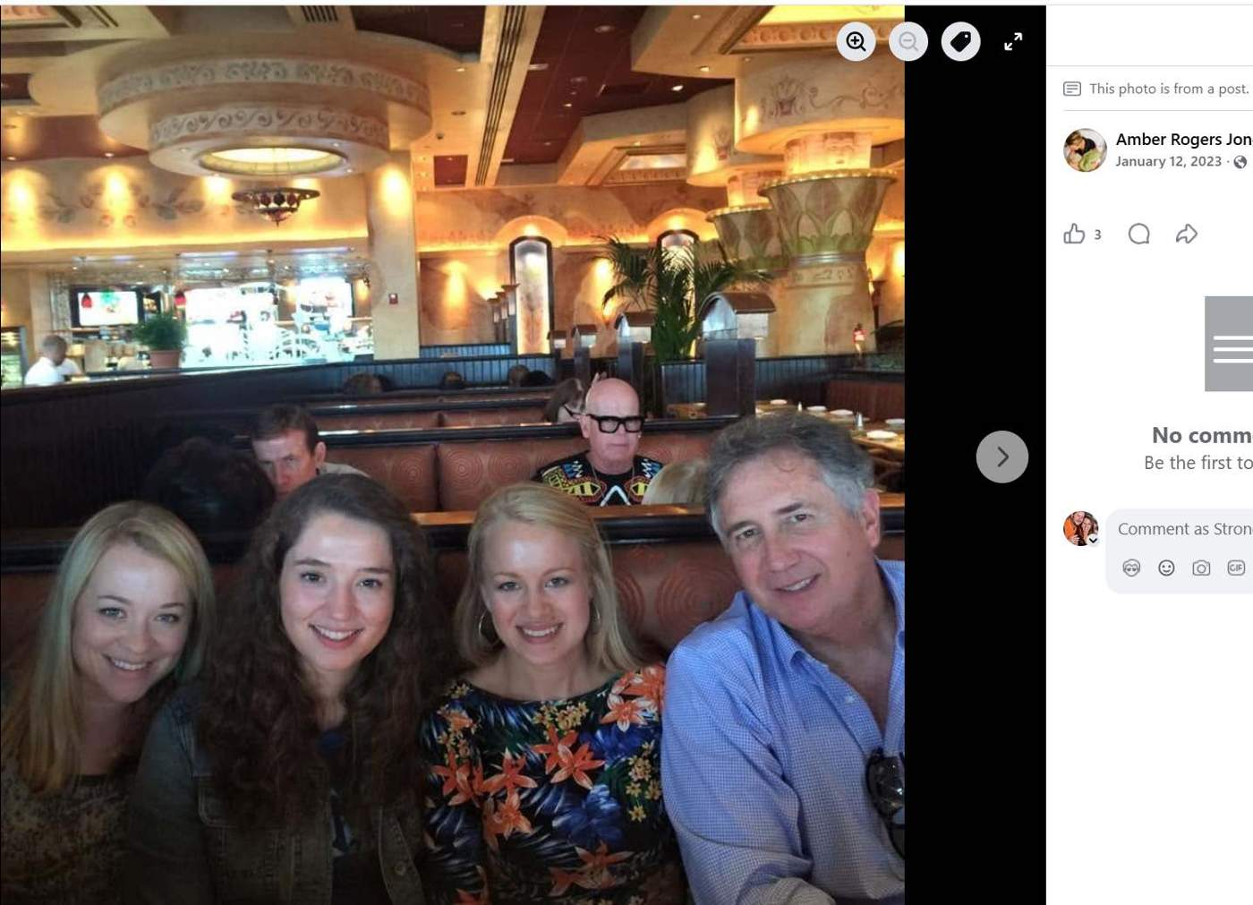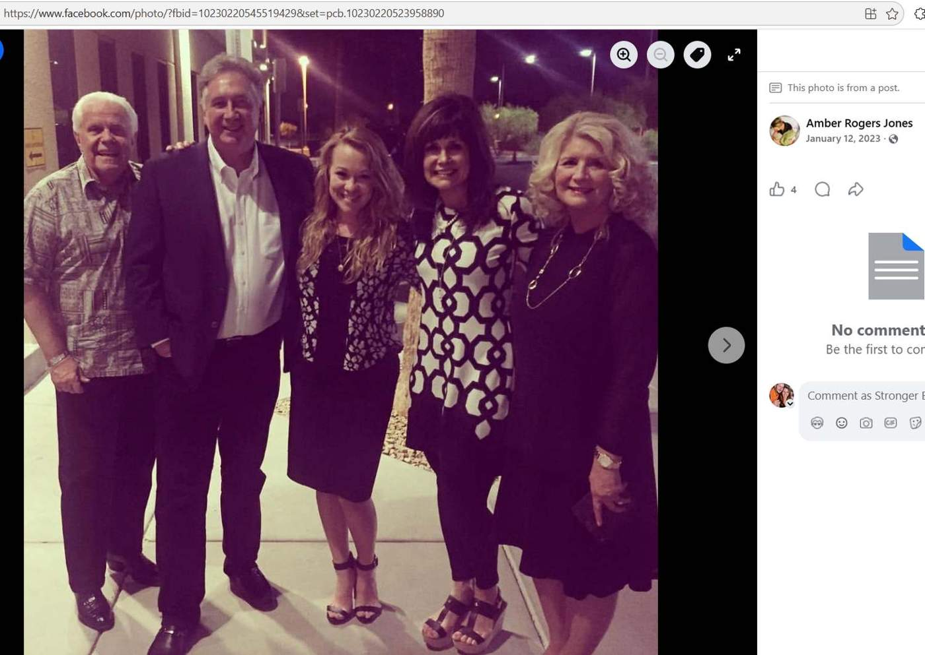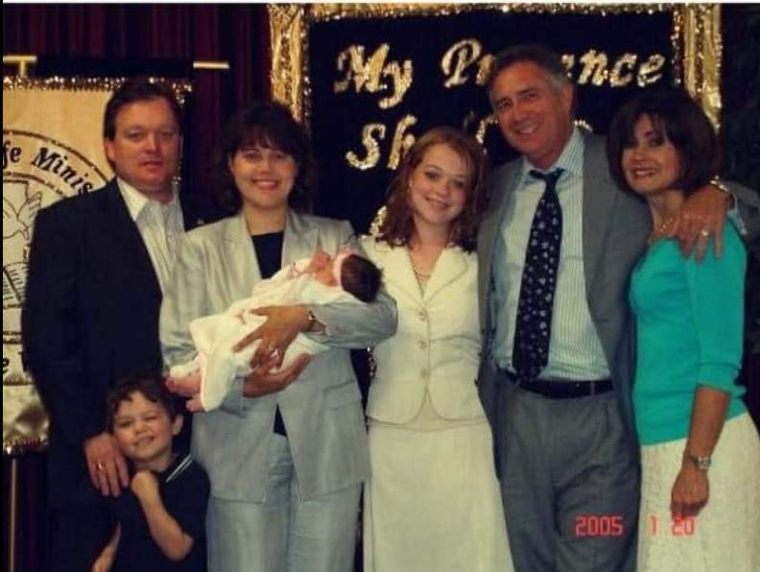
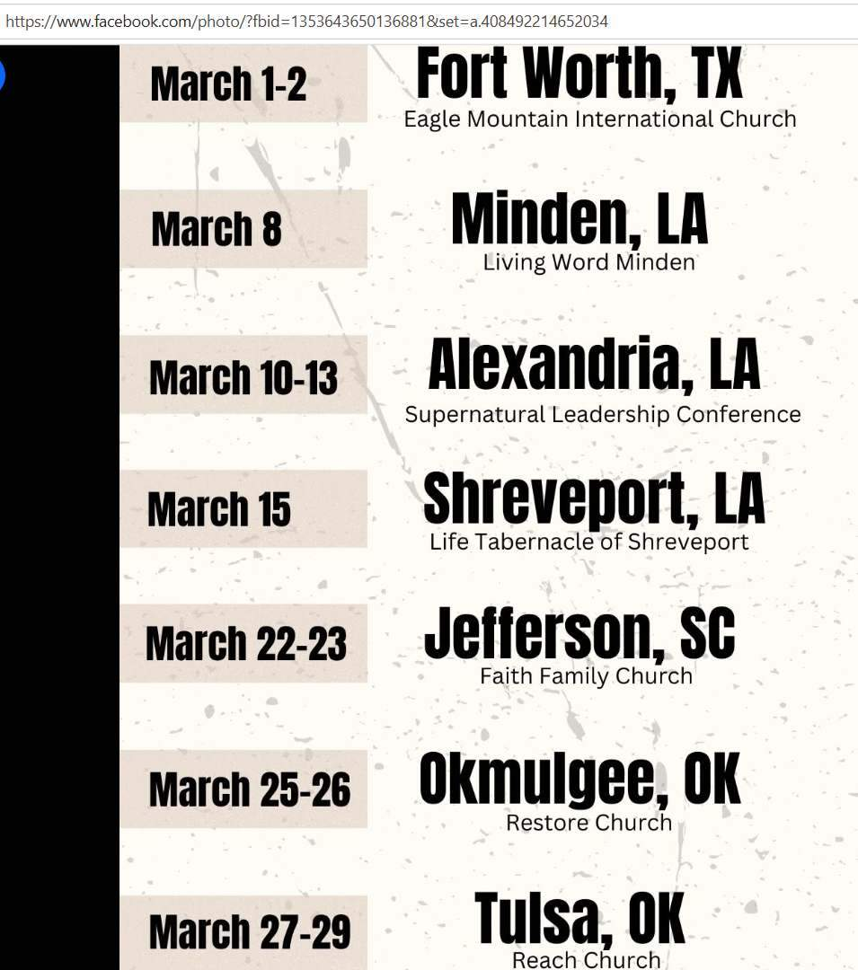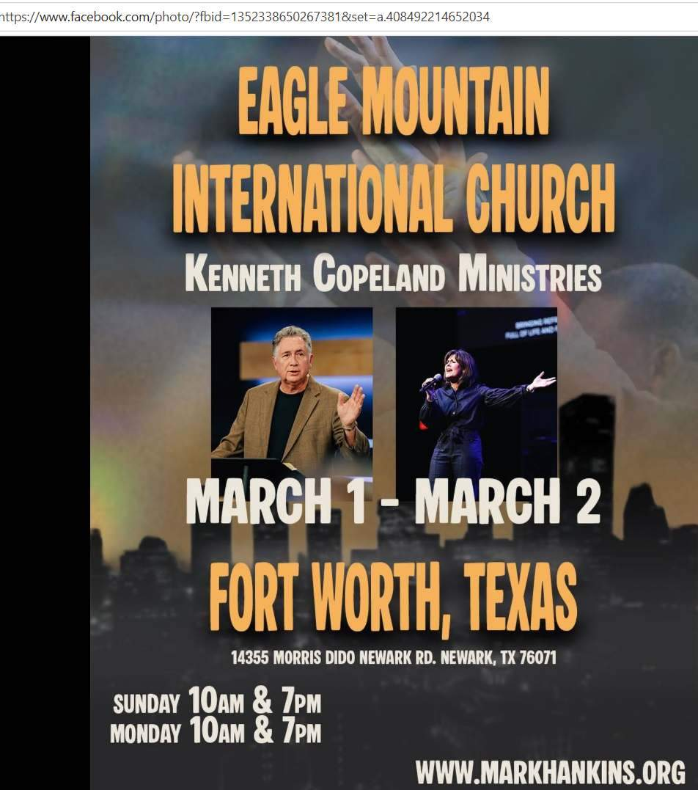
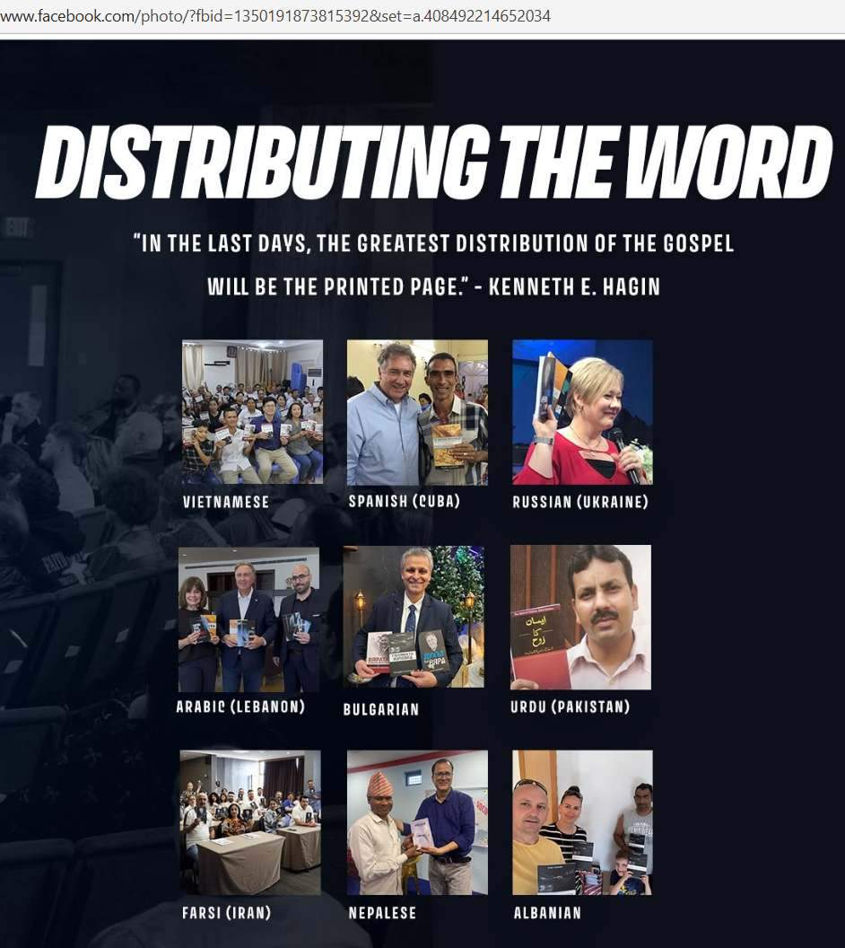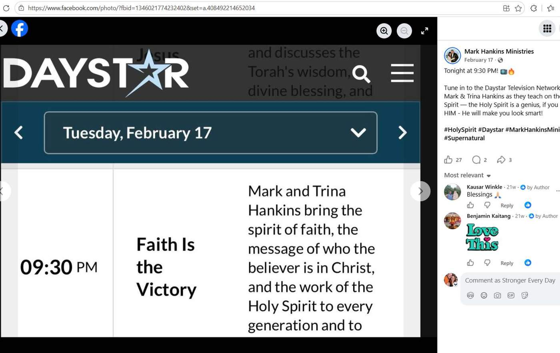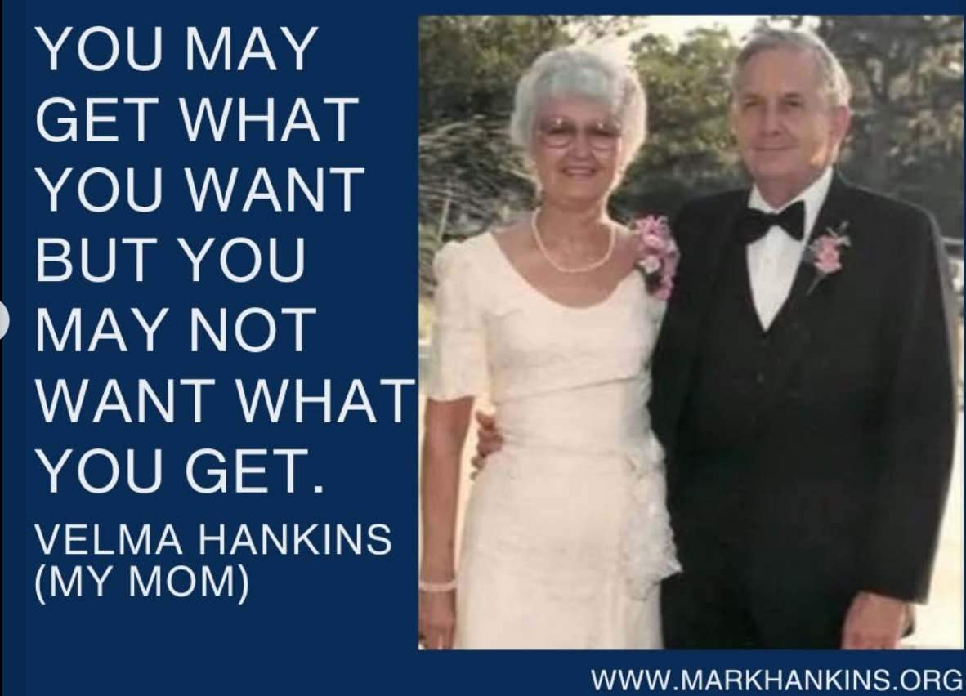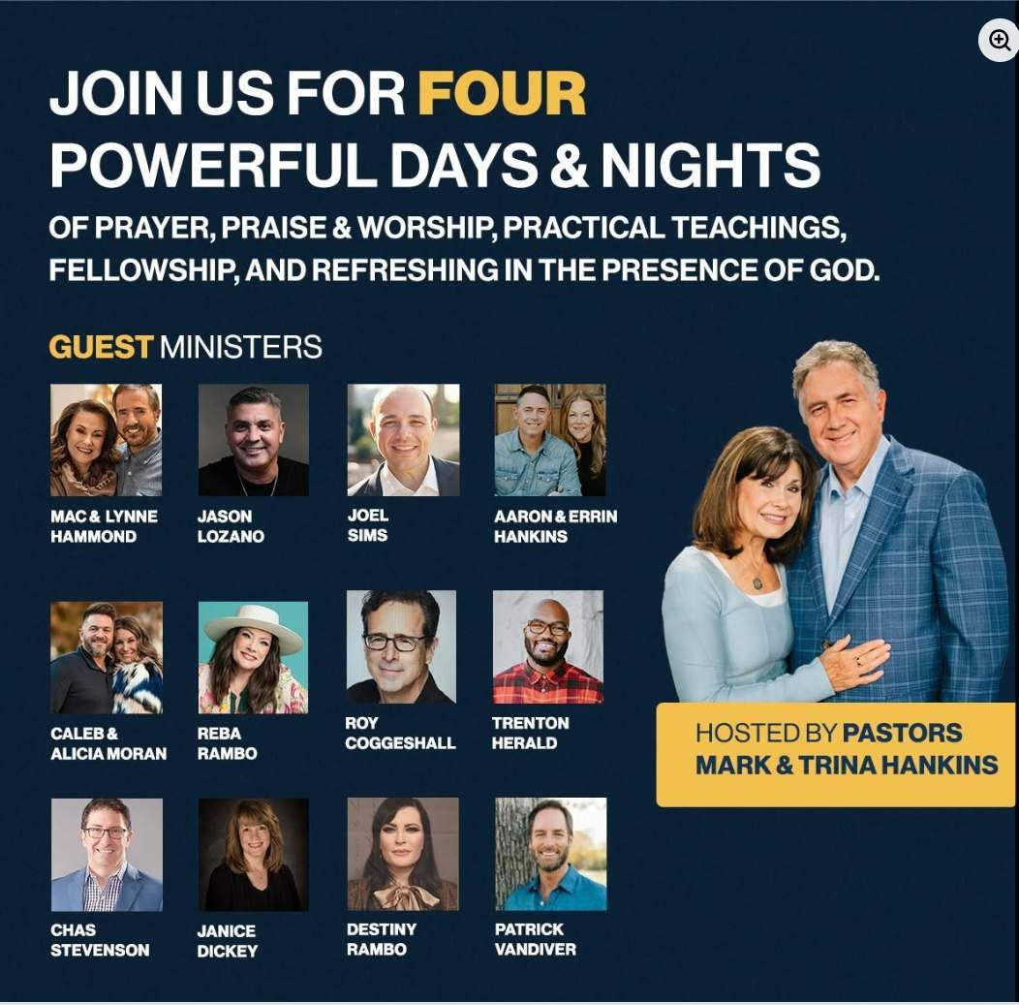
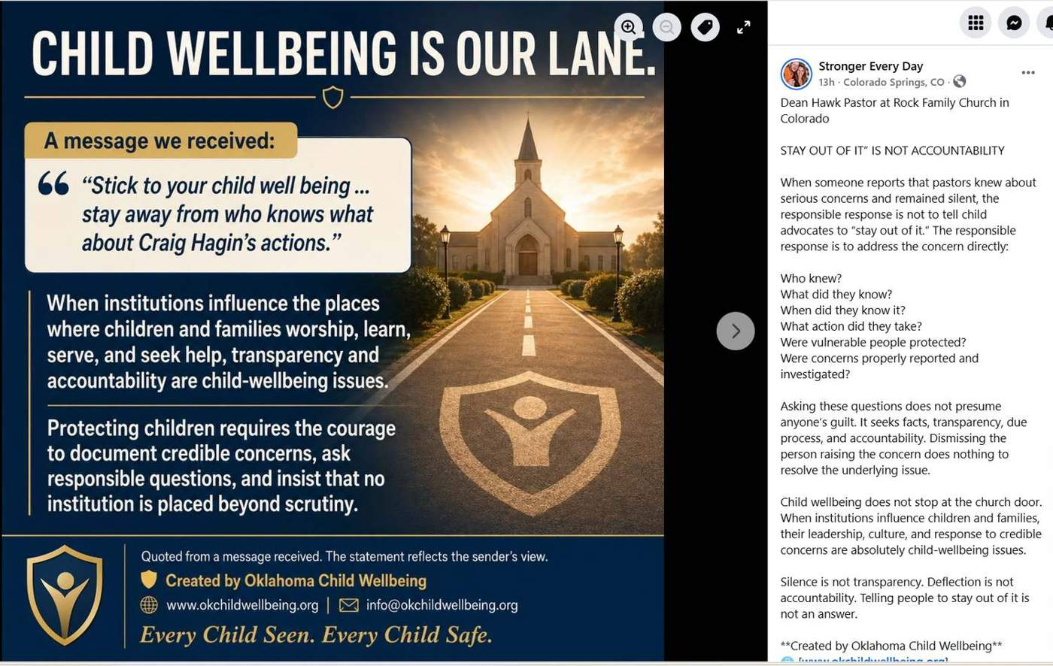
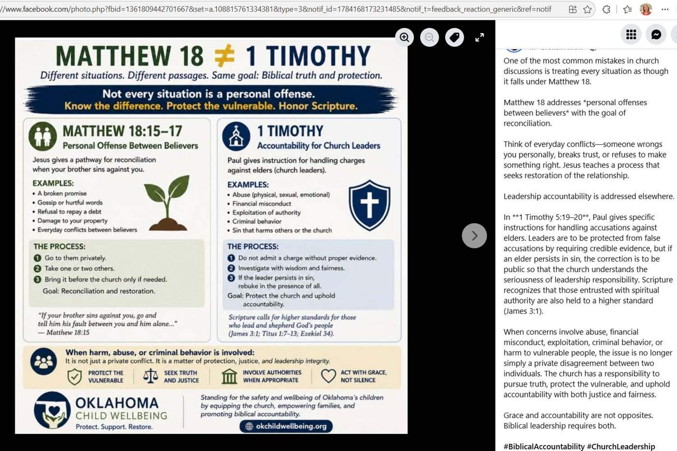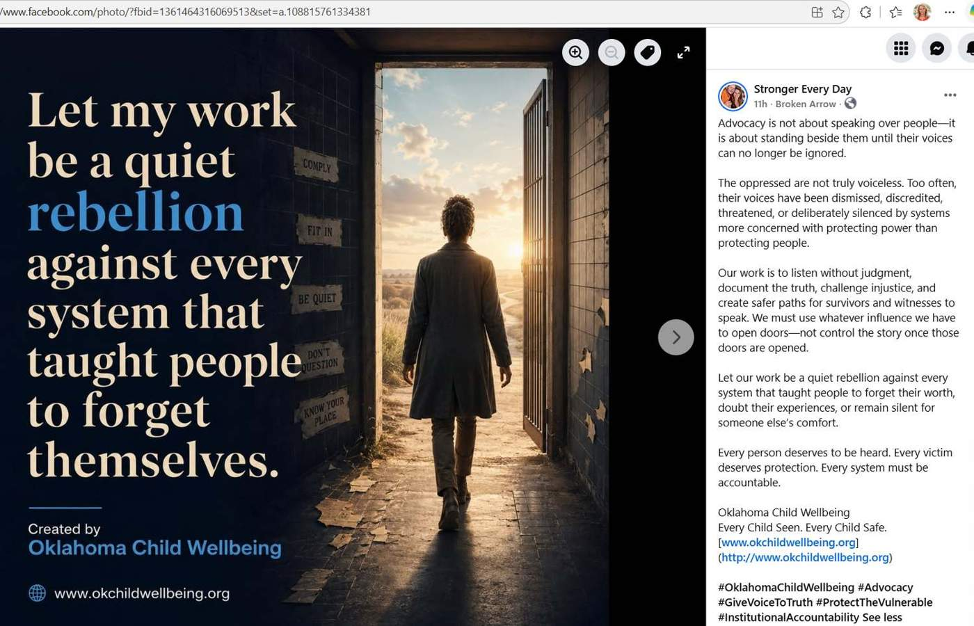
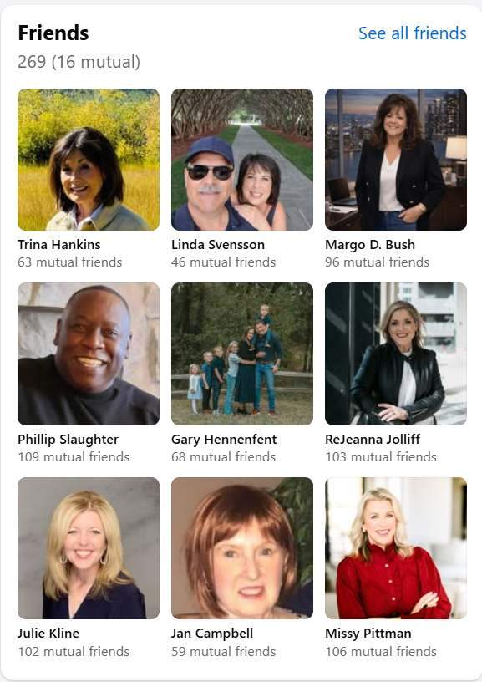

RAYGENE WILSON- Happy 94th birthday to the amazing Rosey Grier! Besides being my favorite LA Ram as a part of the Fearsome Foursome, he’s a real American treasure. He wrestled the gun out of Sirhan Sirhan’s hand when Bobby Kennedy was assassinated. He worked with all the presidents, had his own variety show, was a recording artist, was a regular on the Daniel Boone Show, as well as many other acting roles. Rosey founded many charities still operating today for the disadvantaged. He’s an activist, a preacher, and my friend. I threw a big bash for his 90th—we got another big one coming up this next year! 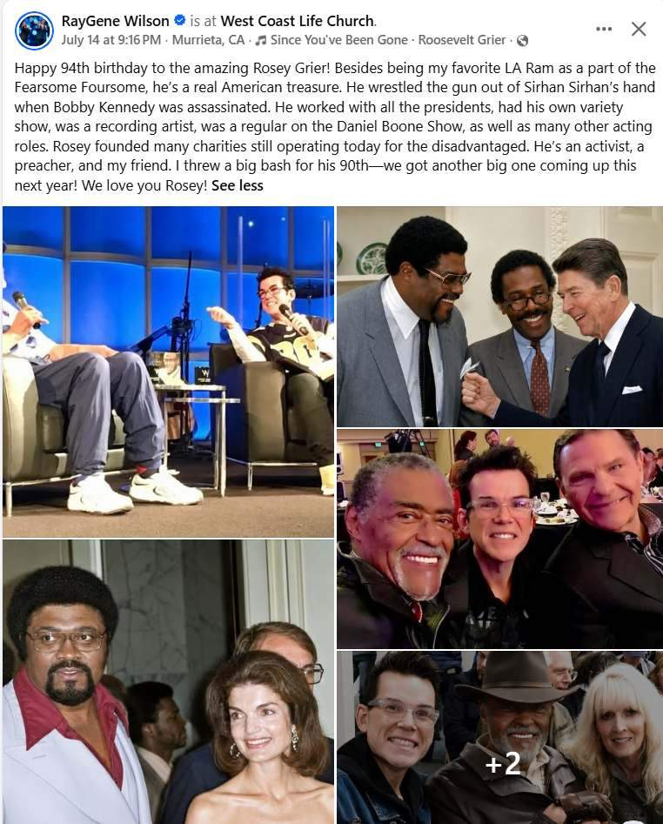
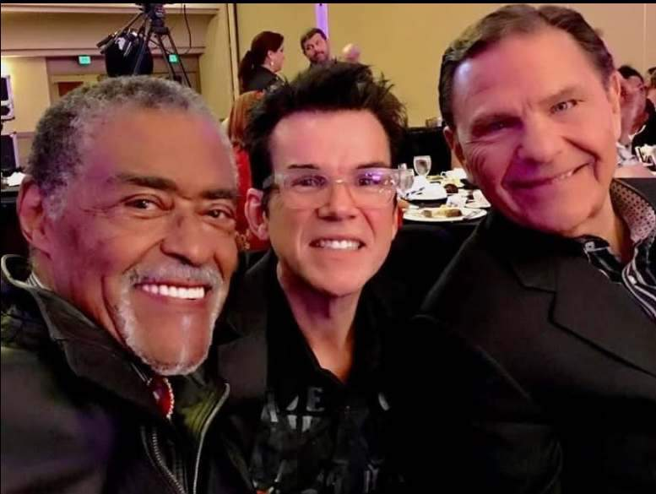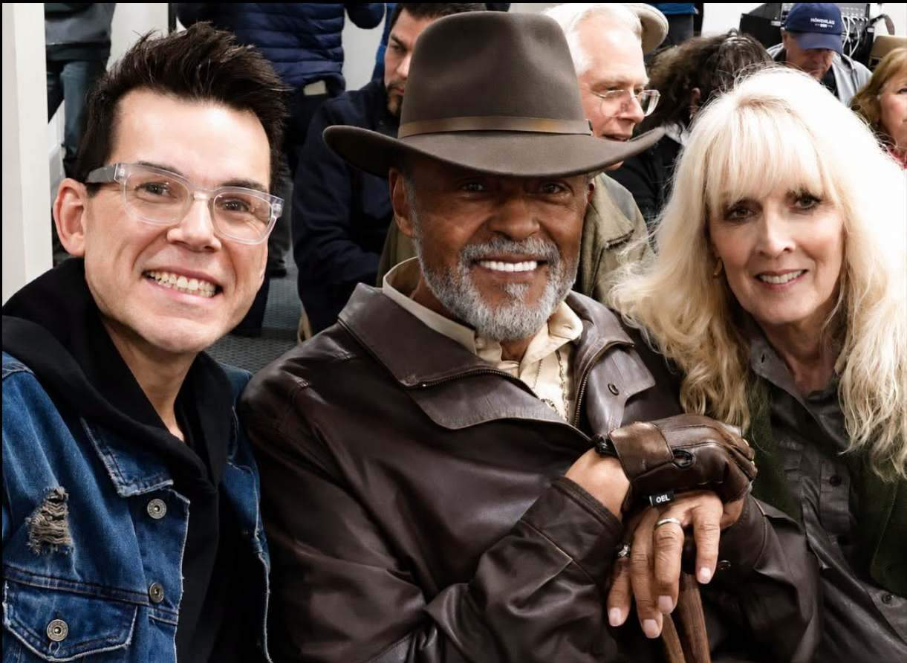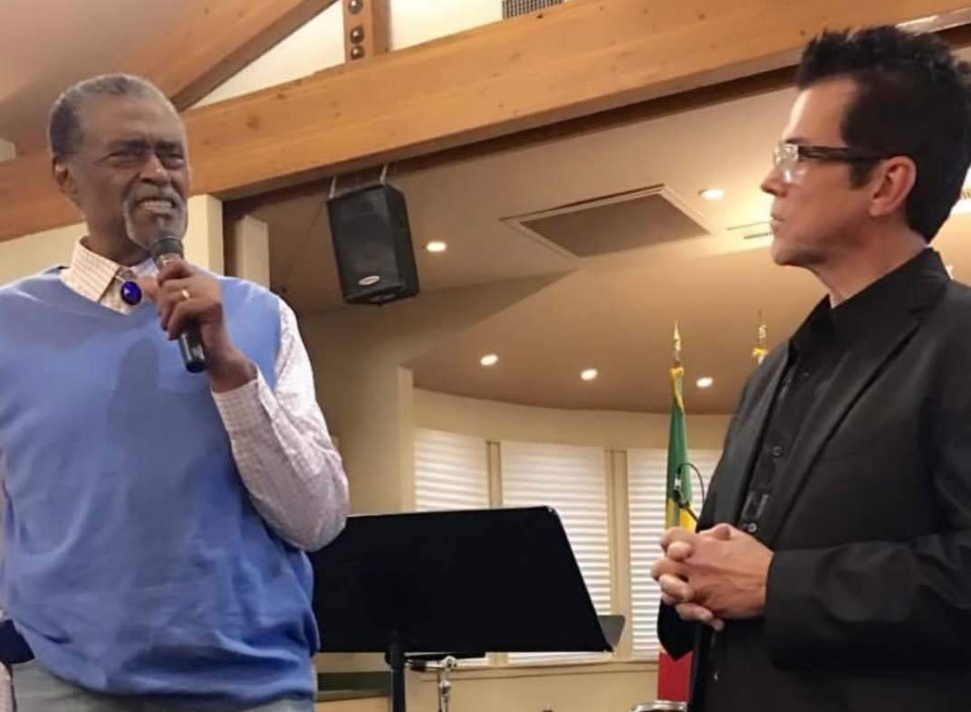

Email received 7/16/2026
I am a 3-year Rhema graduate. Mia was in some of my classes for my first year. I did not have much interaction with her. I didn’t really have any connections with any of the Hagins.
One thing that always bothered me about Rhema had to do with a certain associate pastor that was there for a time. Jay Hoskins. He was brash and kinda class-clownish. But, he was a great speaker. He was honestly the brightest star of the entire place for the like 8 years I went to Rhema. The ministry that he was placed over was Synergy-singles ministry. It THRIVED. It was the place to be when it came around and I felt it was “revival” around there from all the staleness at Rhema.
One day it came out that Pastor Hoskins was being removed from the role, mysteriously. That Sunday Pastor Hagin chided the congregation a bit about that he (Hagin) was your real pastor and you listen to him (generally speaking, not sure of the actual wording. Describing the vibe). There were lots of grumbling and rumors that the Hagins, KHJ in particular, were threatened of being outshined.
I know this sounds to have nothing to do with Craig’s situation. But, I think that’s it does. It sets the attitude of the Hagins and how they seem to be above anyone and everything around them. They didn’t want the people to see what real ministry was all about or looked like. Just keep people trapped in their blab it, grab it crap.
I think there’s way way way more to the Hoskins story than what has been brought to the light. Would love to see anything more on that to see if my observations are true about the Hagins attitude.


Me at Life Revolution Church Amy & Josh Samples
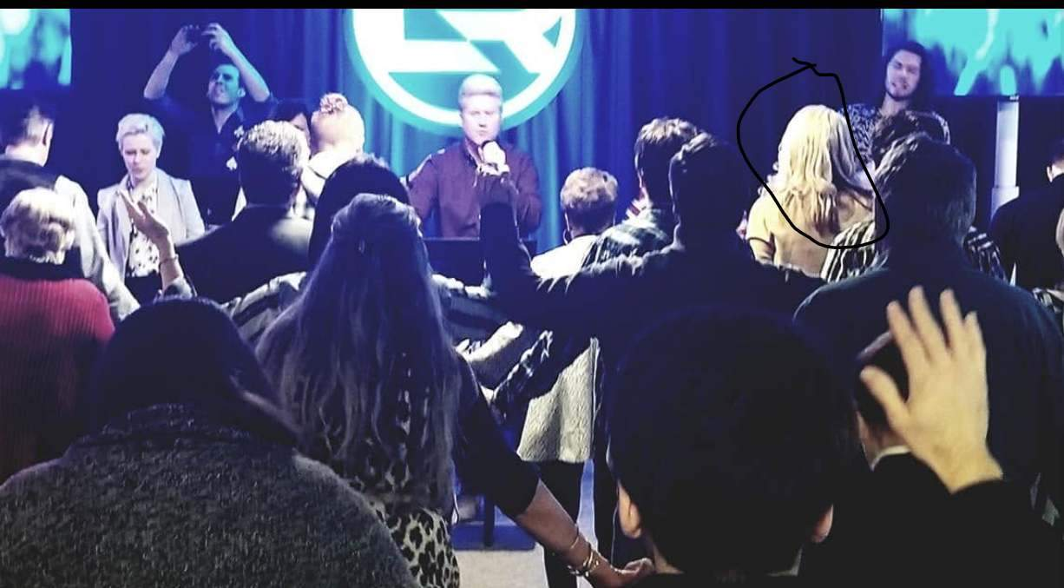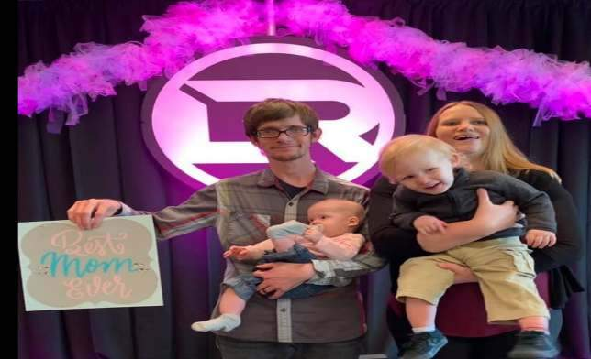
Me at Life Church in 5/2019
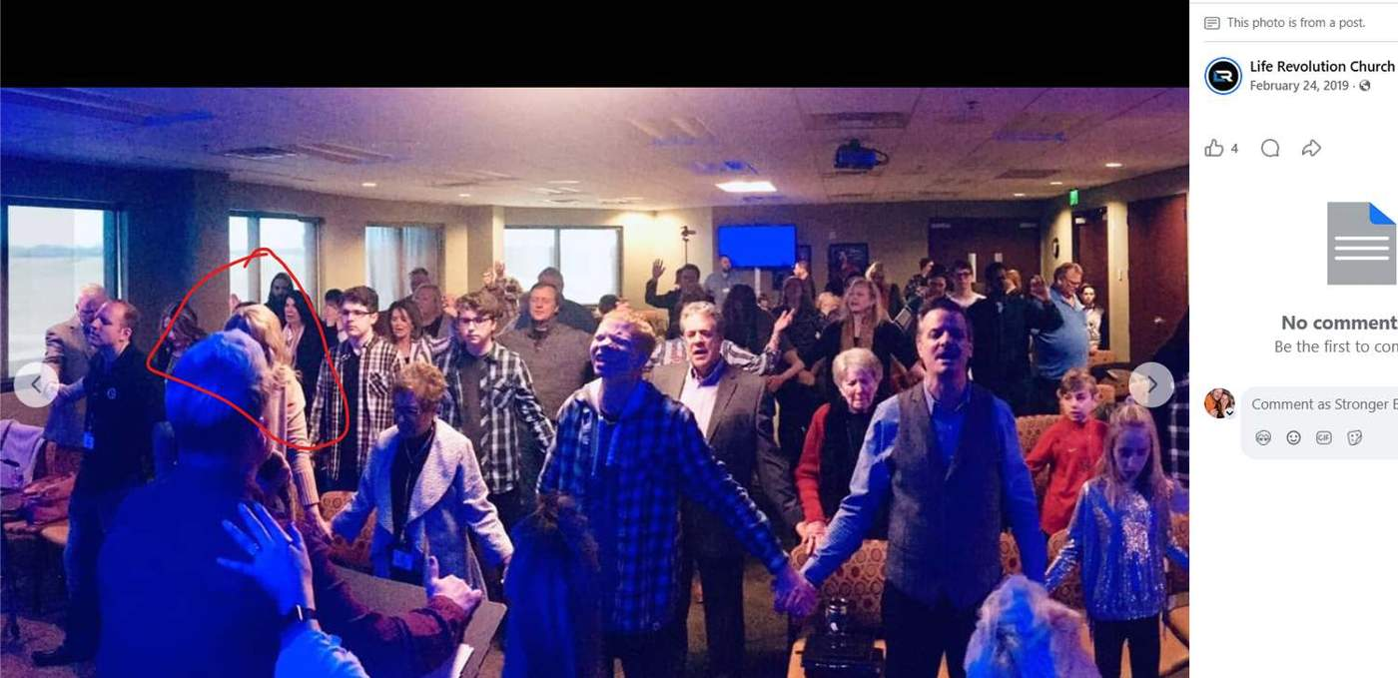
Caleb, Carissa, Gabriel Pape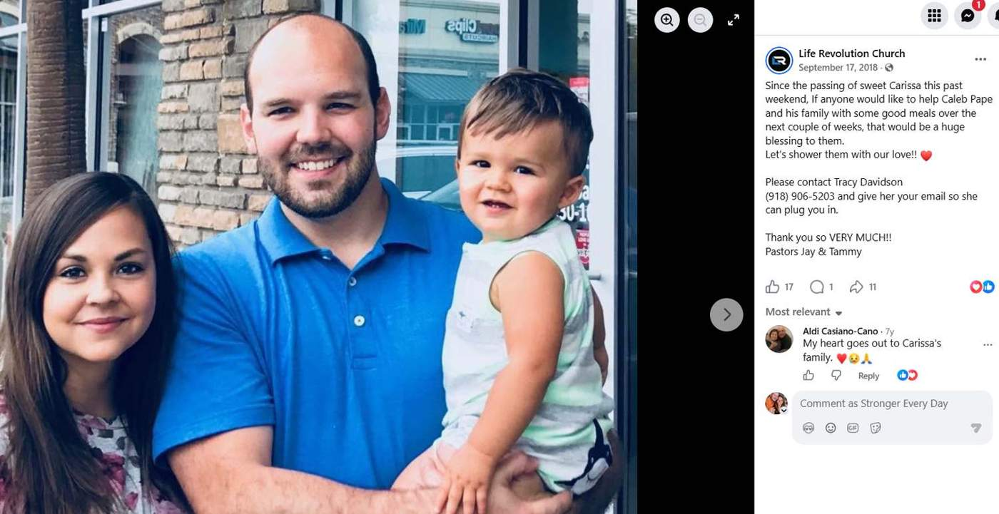

Me at LRC in May of 2018 when I supported Safari Missions (Rhema Vidar and Catherine Ligard) Safari Mission - Seeing Christ’s redemptive work realized in all areas in East Africa
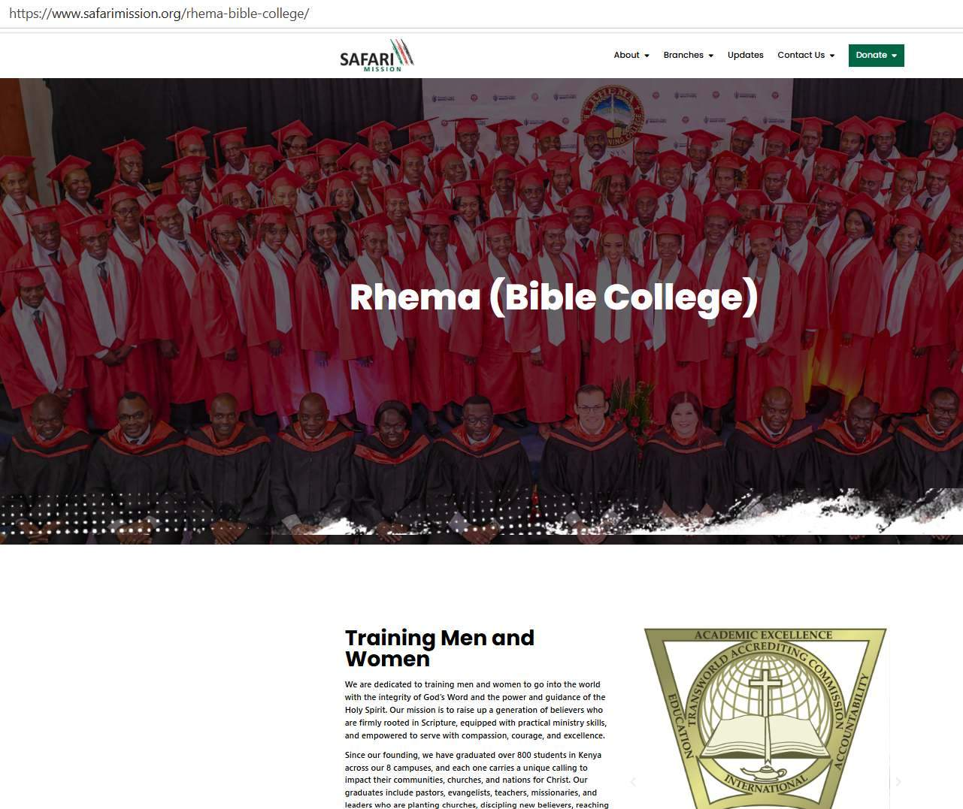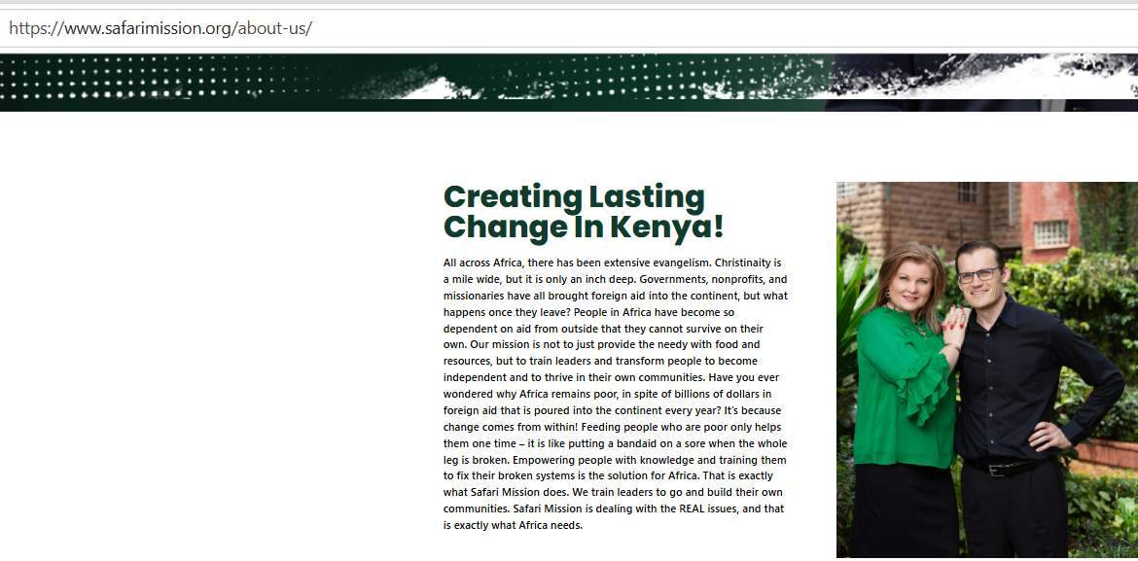
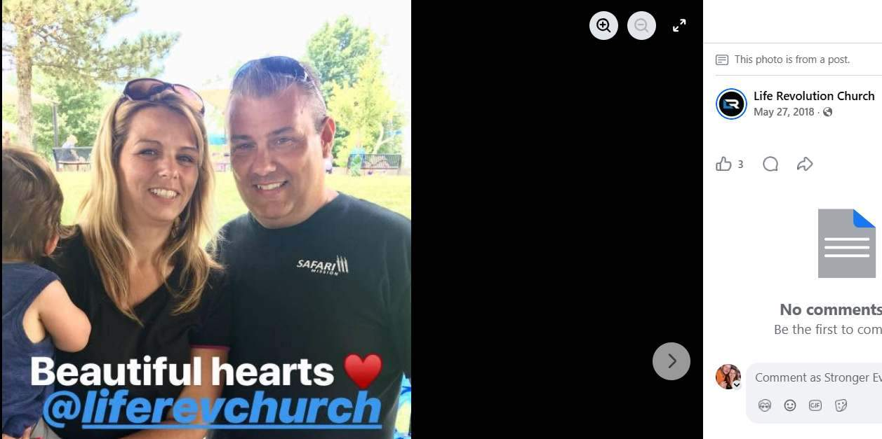
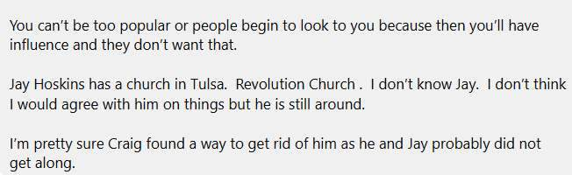
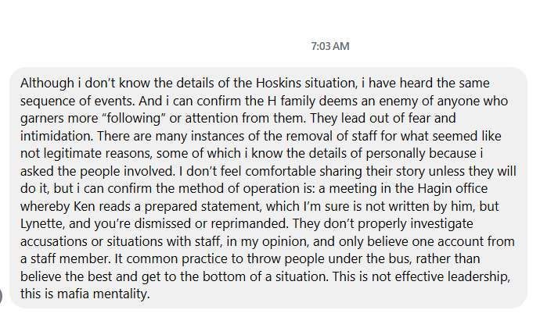
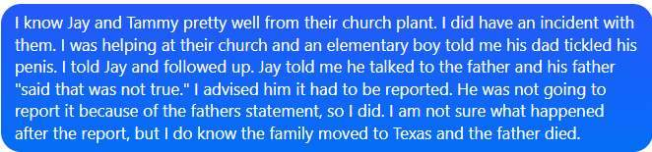

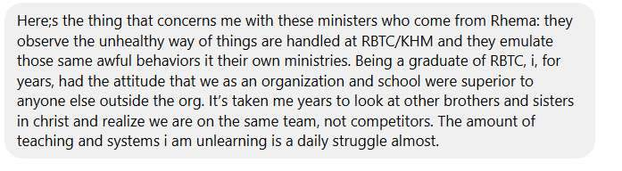
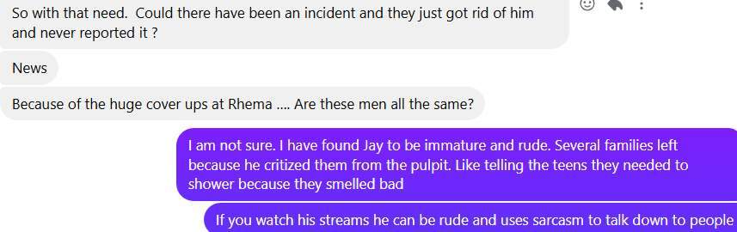

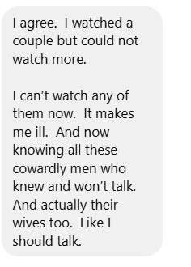

My personal reflection from my time with Life Revolution. As with anything nothing is all good or bad, there is a mixture of positive with negative so you have to weigh those things out. Pastor Jay Hoskins and Tammy Hoskins were probably the most accessible pastors I have interacted with. We went to the movies together, and Tammy joined me at a Comedy show in Arkansas with my pastor friend at the time (Her and her husband Troy Marino and Taffi Marino stopped speaking to me after the divorce of my first husband who was charged in the state of Oklahoma for abuse.)
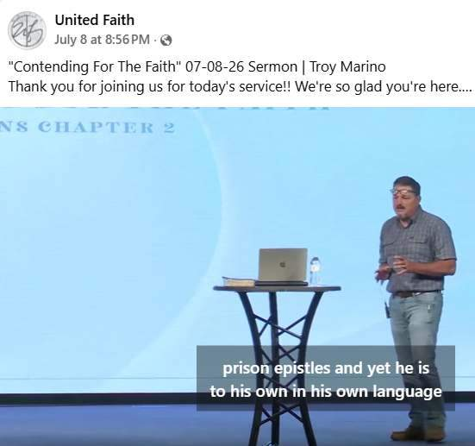
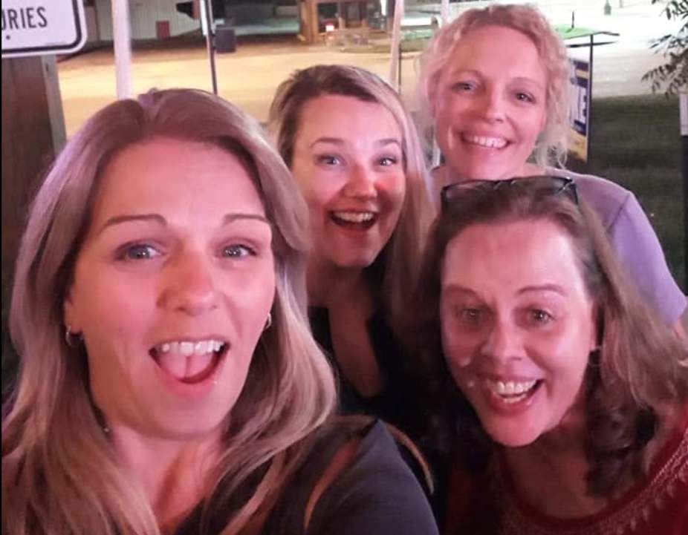
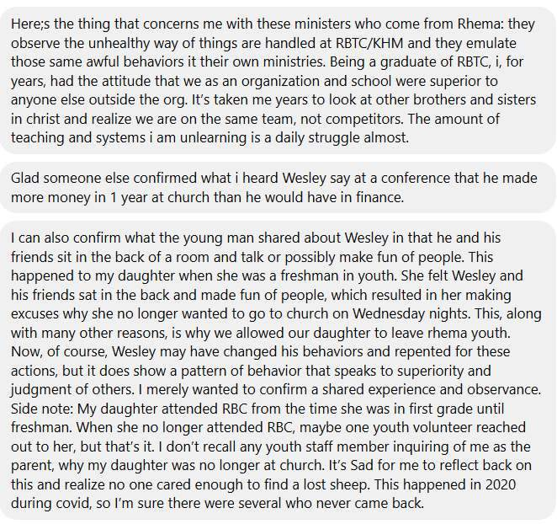

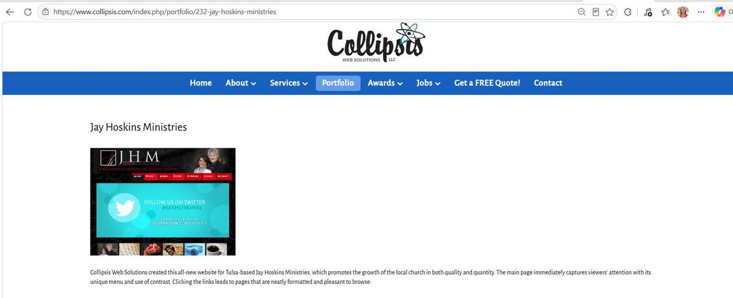
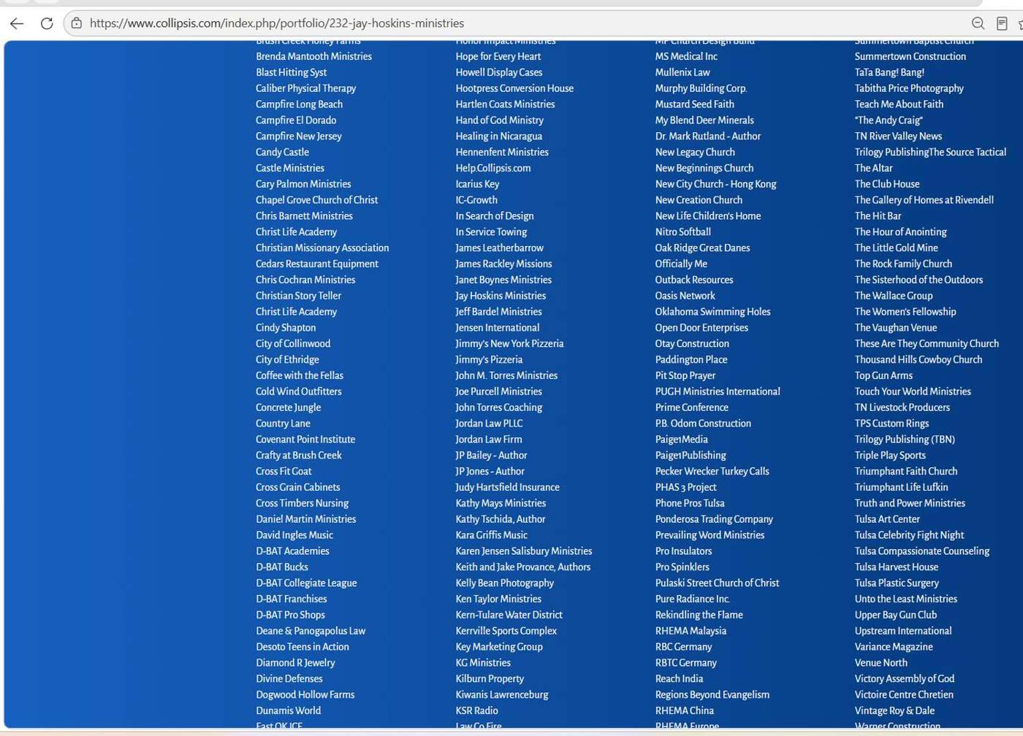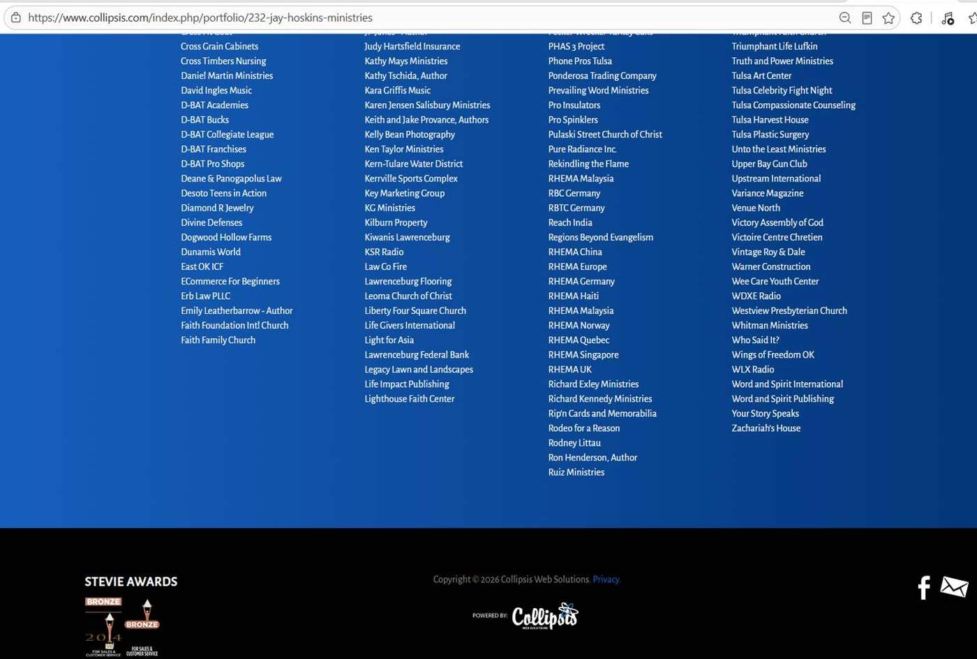
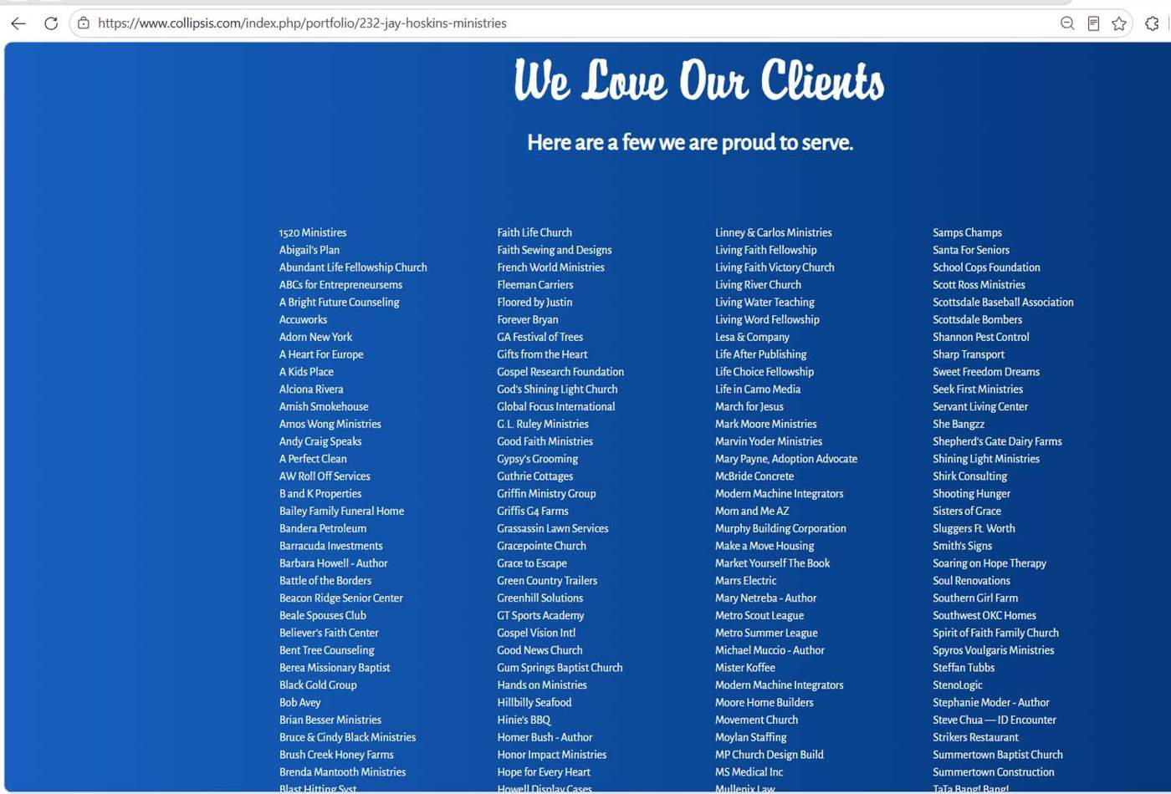

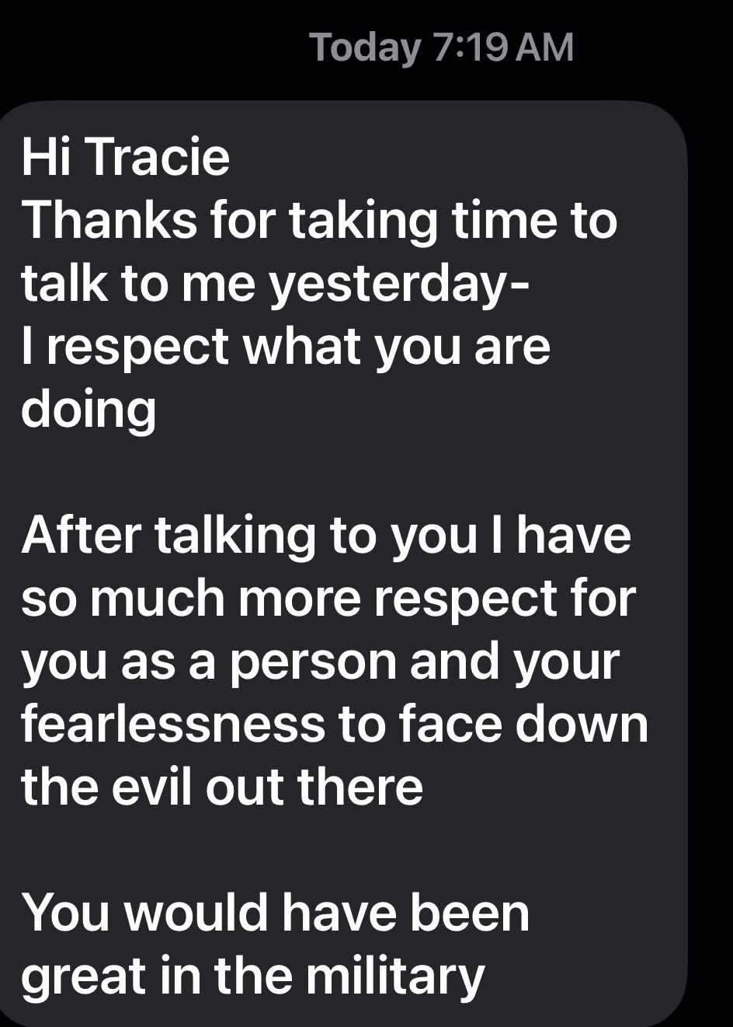

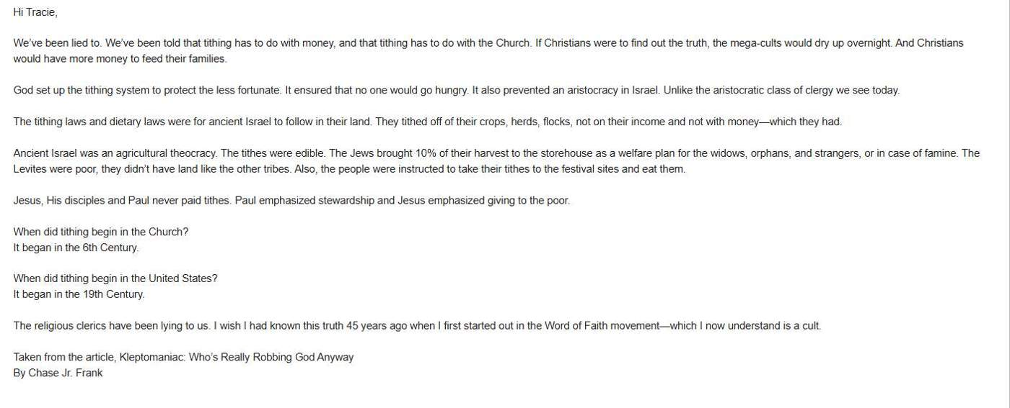

“We’ve been lied to. We’ve been told that tithing has to do with money, and that tithing has to do with the Church. If Christians were to find out the truth, the mega-cults would dry up overnight. And Christians would have more money to feed their families.
God set up the tithing system to protect the less fortunate. It ensured that no one would go hungry. It also prevented an aristocracy in Israel. Unlike the aristocratic class of clergy we see today.
The tithing laws and dietary laws were for ancient Israel to follow in their land. They tithed off of their crops, herds, flocks, not on their income and not with money—which they had.
Ancient Israel was an agricultural theocracy. The tithes were edible. The Jews brought 10% of their harvest to the storehouse as a welfare plan for the widows, orphans, and strangers, or in case of famine. The Levites were poor, they didn’t have land like the other tribes. Also, the people were instructed to take their tithes to the festival sites and eat them.
Jesus, His disciples and Paul never paid tithes. Paul emphasized stewardship and Jesus emphasized giving to the poor.
When did tithing begin in the Church?
It began in the 6th Century.
When did tithing begin in the United States?
It began in the 19th Century.
The religious clerics have been lying to us. I wish I had known this truth 45 years ago when I first started out in the Word of Faith movement—which I now understand is a cult.
Taken from the article, Kleptomaniac: Who’s Really Robbing God Anyway
By Chase Jr. Frank

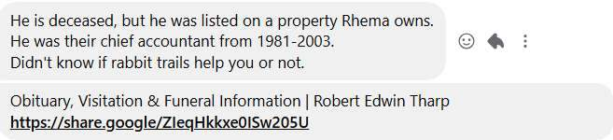
Obituary, Visitation & Funeral Information | Robert Edwin Tharp
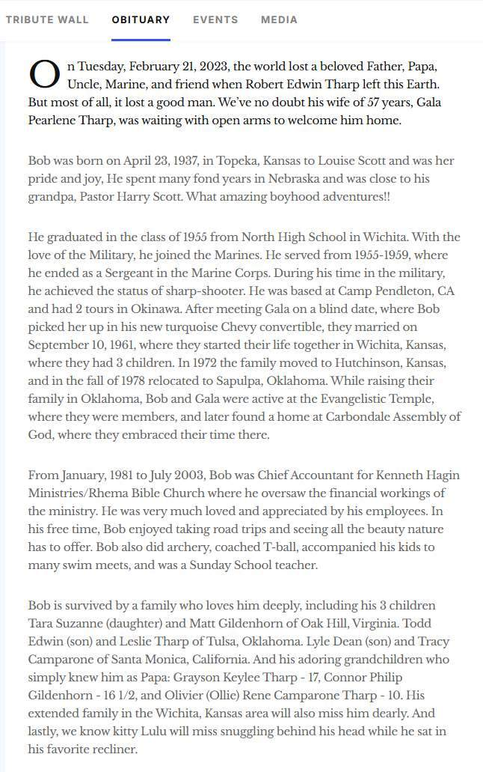

Jul 17, 2026,
This is ________ from Indiana. I saw your interview with Everett regarding the dilemma in Tulsa with lacking accountability in the Rhema network. I've been tracking this and several other similar institutions and circles over the past several years. This one hits a little home because of a church I used to be associated with years ago, and its close connection with Rhema.
Thank you for taking the time to share your observations and experiences and getting the word out to people that need to hear it that didn't know, as well as those who did know but were too shy or afraid to speak up. And to those who have survived such things, to be a voice for them and to help empower them in their own journey.
Separately, I see your website, I love the resource that you are providing for the community with this. This is beautiful.
Not sure that you have the time or bandwidth, but it would be very interesting to connect and talk to share stories and experiences, and what God is doing in hearts regarding this issue.
Grace and peace…
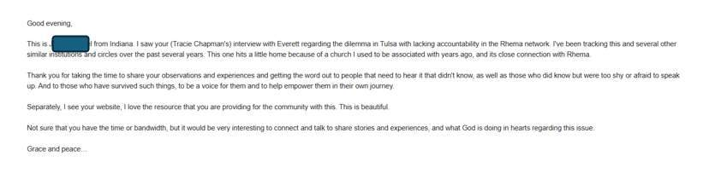
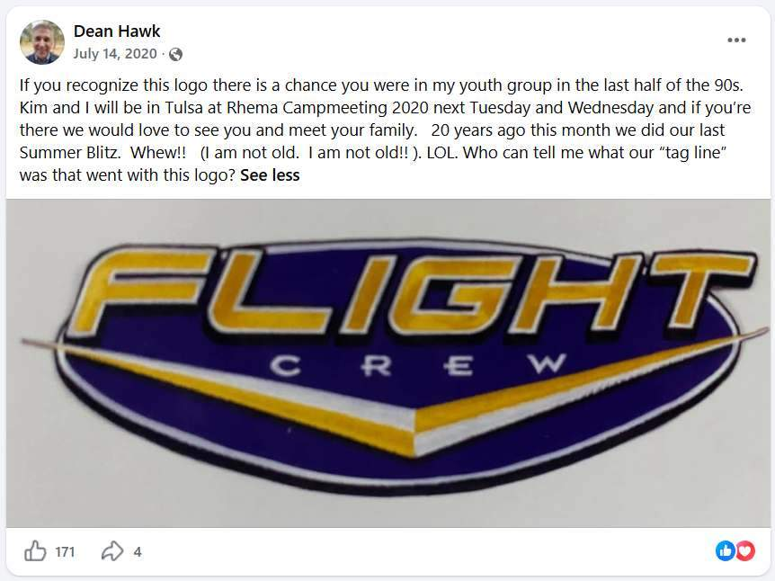
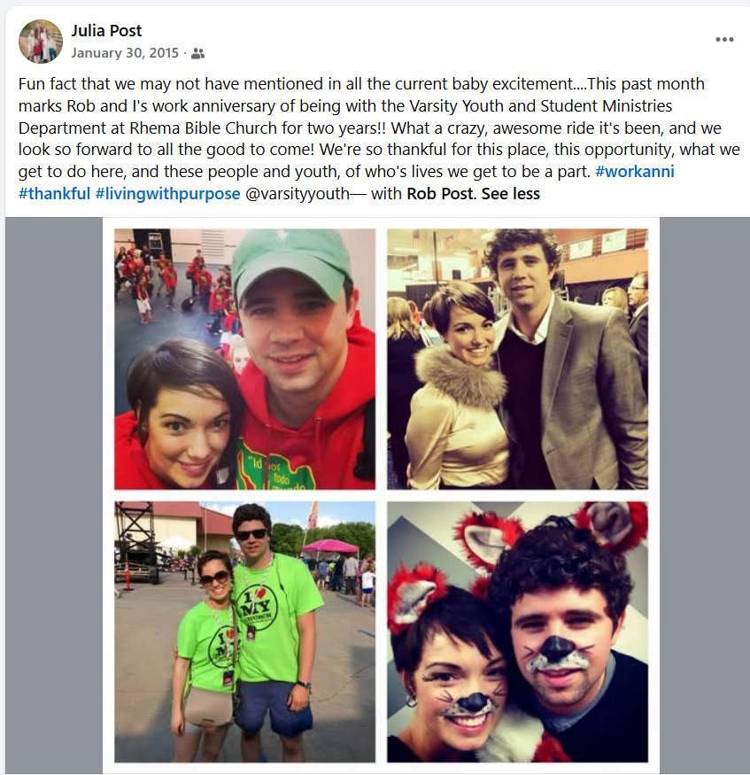
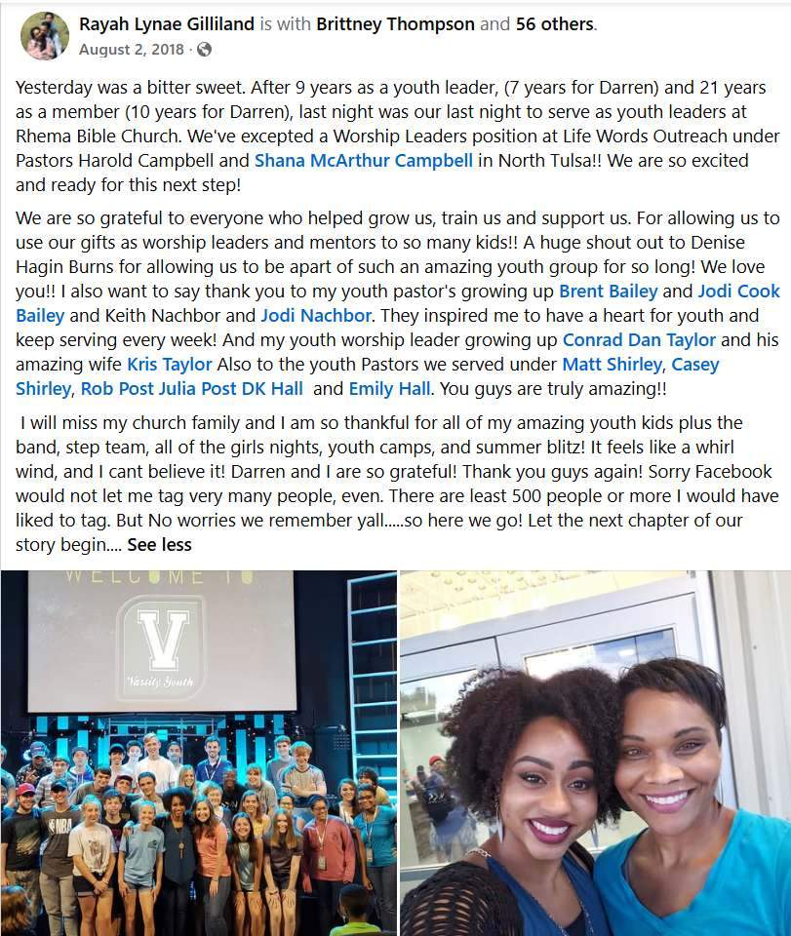
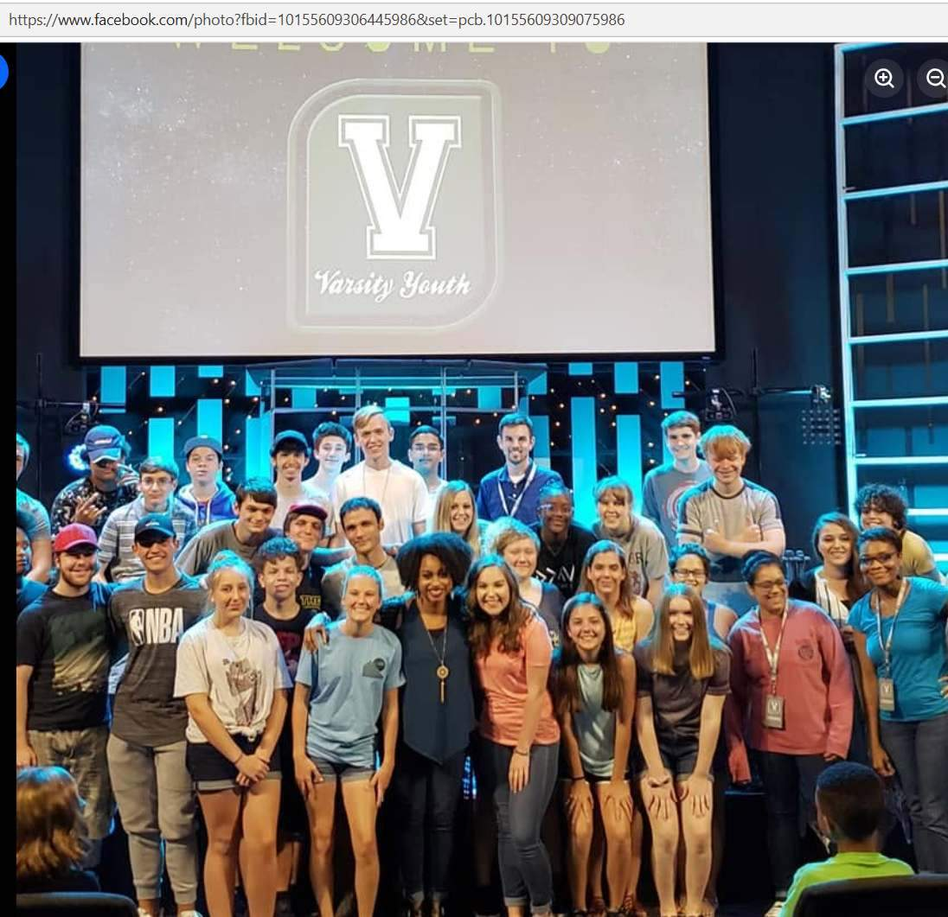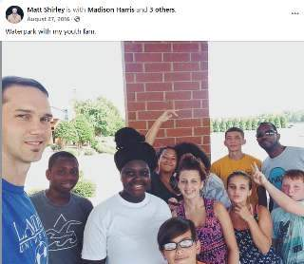

RHEMA YOUTH Names
Flight Crew
Rhema Axis
Rhema Youth
Varsity Youth
Dean Crowl, Rob and Julia Post, Emilee & DK Hall, Craig Hagin, Keith Neighbor, Brent Bailey, Denise Hagin, Conrad Dan Taylor, Zachariah and Ashley Morris, Marianna Moore,
WHAT HAPPENED ON THE MISSION TRIPS and IN THE YOUTH GROUP? WHY DID PEOPLE GET REMOVED FROM LEADERSHIP?
Where is Jackson Lahmeyer this week I wonder what he is focused in on?

